**GANDHI INSTITUTE OF TECHNOLOGY AND MANAGEMENT (GITAM)**

(DEEMED TO BE UNIVERSITY)

**DEPARTMENT OF COMPUTER SCIENCE AND ENGINEERING**

(GITAM INSTITUTE OF TECHNOLOGY)



MINI – pROJECT

ON

Airlines and Airport Management

EID 321: DATABASE MANAGEMENT SYSTEMS LABORATORY

BY

**group – 4**

**KATI SILAS SWARNAKANTH (1215316926)**

**Kesarapu Midhun (1215316927)**

**Andalam Kavya (1215316905)**

**Madhuresh Kumar (1215316933)**

sECTION

B-19 (S), 3/4, CSE

YEAR

2017 – 2018

ACKNOWLEDGEMENT

We would like to express our special thanks of gratitude to our professor, **MRS. G. HIMAJA** as well as our HoD, **Dr. Konala Thammi Reddy** who gave us the golden opportunity to do this wonderful mini project on the topic **AIRLINES AND AIRPORT MANAGEMENT**, which also helped us in doing a lot of research and enhance our knowledge on the subject by practically applying the theoretical concepts learnt in the classes. It also helped us to know about so many new things. We are thankful to them.

Table of Contents

1. **PROJECT DESCRIPTION**

**1.1 Requirements of the Database System**

1. **ENTITIES**
2. **MAPPING ER DIAGRAM TO RELATIONAL SCHEMA**
3. **ER/EER DIAGRAM**
4. **RELATIONAL SCHEMA**
5. **NORMALIZATION RULES ON DATABASE**
6. **NORMALISED RELATIONAL SCHEMA**
7. **SQL**
8. **STORED PROCEDURE**
9. **TRIGGERS**
10. **BUSINESS RULES**
11. **JDBC CONNECTION TO DATABASE**
12. **FRONT-END IMPLEMENTATION**
13. PROJECT DESCRIPTION

**Domain**: Airlines and Airport Management

**Task:**

**Major Airline Companies that provide services share a Database across Airports Internationally with all the following information:**

* **Each Airport has its Name, City, State and Country.**
* **Each Airline has an ID Number, Name, Code, Name of Contact Person and Phone Number.**
* **Each Aircraft has a Code, Arrival and Departure Times, Duration, Status, Model and Capacity.**
* **Each Route has a Route Number, Source, Destination and Distance.**
* **Each Passenger has an ID, Passport Number, First, Middle, Last Names, Sex, Address, Age and Phone Number.**
* **Each Ticket has a Number, Class, Price, Source, Destination, Seat Number and Date. (A ticket can be booked as well as cancelled)**
* **Each Employee has an ID, First, Middle, and Last Names, Age, Sex, Address, Job Type, Salary, Phone Number.**
  1. Requirements of the Database System:
* The system is based on airlines management. Airlines management system primarily deals with the management of airport, airlines and passengers. The system provides a broad overview of underlying operational factors that influence the airline's management.
* The database system has the data of all commercial service aircraft and airports.
* Every airline is identified uniquely by an airline code. Airline code is a two-letter airline designator. The airline also has three-digit code which is printed on an air ticket.

Airline Code

|  |  |  |
| --- | --- | --- |
| Airline Name | Airline code/IATA Designator | 3-DIGIT CODE |
| American Airlines | AA | 001 |
| Air India Limited | AI | 098 |
| Lufthansa | LH | 220 |
| British Airways | BA | 125 |
| Qatar Airways | QR | 157 |
| Jet Airways | 9W | 589 |
| Emirates | EK | 176 |
| Etihad Airways | EY | 607 |

Reference: <http://www.iata.org/publications/Pages/code-search.aspx>

* Airline companies serve flights.
* Every flight is uniquely identified by a flight code. Flight code is a combination of an airline code and four-digit number.
* The flight takes off from one airport and lands at another airport. Therefore, a most important aspect of a flight is its route, the source and destination. Source and destination airports are identified using an airport's IATA code.
* International Air Transport Airport code is simply a location identifier. IATA code is a three-letter code designating many airports across the world. These codes are prominently displayed on baggage tags and printed on an air ticket.

Airport Code

|  |  |
| --- | --- |
| Airport Name | IATA Airport code |
| Louisville International Airport | SDF |
| Chandigarh International Airport | IXC |
| Dallas/Fort Worth International Airport | DFW |
| Indira Gandhi International Airport | DEL |
| Chhatrapati Shivaji International Airport | BOM |
| San Francisco International Airport | SFO |
| Frankfurt Airport | FRA |
| George Bush Intercontinental Airport | IAH |
| John F. Kennedy International Airport | JFK |
| Tampa International Airport | TPA |

Reference: <http://www.iata.org/publications/Pages/code-search.aspx>

* Flight has an arrival time, departure time, duration. Flight has three types of classes: business, economy and first class.
* Flight can be of two types such as non-stop flight and a connecting flight.
* Connecting flight is a flight which takes an intermediate stop and changes a flight possibly change of an airline. But we are assuming that connecting flight does not change a flight that is at each stop, after layover time gets over, passengers aboard the same flight.
* Flight serves passengers. Flight carries passengers from source to destination.
* A passenger is uniquely identified by a passenger id and a passport number.
  + Every passenger has details such as name, address, age, sex, phone.
* For a passenger to travel by a flight, he needs a ticket. A ticket or air ticket is used to confirm that an individual has reserved a seat on a flight. With the ticket, a passenger is allowed to board the flight.
  + An air ticket has information such as the passenger's name, the issuing airline, ticket number, source, destination, journey date, seat no, class, fare.
  + The ticket number is the combination of airline's 3-digit code, 4-digit form number, 6-digit serial number.



* Hence, depending on the airline, source, destination, journey date and most importantly class, which a passenger chooses fare or price of an air ticket is determined.
* A passenger can book one or multiple tickets. The day on which the passenger books an air ticket is a booking date. Similarly, a passenger can cancel one or multiple tickets. The day on which he cancels an air ticket is cancellation date, and there will be a surcharge that a passenger has to pay after cancelling a ticket.
* Every airport has employees working for it.
  + Every employee is identified by SSN. Every employee has an information such name, address, phone, age, sex, salary.
  + The Employees in the role of administrative support, engineer, traffic controller and airport authority work at the airport.
  + Every airline needs administrative support staff to keep the office running smoothly. The different positions include secretaries, data entry workers, receptionists, communications and PR specialists and human resources department.
  + There are different types of engineers who work specifically with information technologies, electronics, flight structure, environmental regulations, etc.
  + Traffic Monitor works in different shifts such as day or night.
  + There are different positions that airport authorities might work at such as manager, attendee, assistant, pilot, etc.
* Employees working in the role of administrative support may help passengers with various tasks such as booking a flight ticket, solving passenger's questions, etc.

**Assumptions:**

* The system is designed only for international flights.
* For Connecting flights, flight and airline remains the same at layover stops
* There are different types of jobs available at the airport. For simplicity, our system considers a few jobs only.

1. ENTITIES

**AIRPORT**

|  |  |  |  |
| --- | --- | --- | --- |
| AP_NAME | STATE | COUNTRY | CNAME |

**AIRLINE**

|  |  |  |  |
| --- | --- | --- | --- |
| AIRLINEID | AL_NAME | THREE_DIGIT_CODE | PH |

**AIRCRAFT**

|  |  |  |  |  |
| --- | --- | --- | --- | --- |
| AIRCRAFT_CODE | ARRIVAL | DEPARTURE | MODEL | STATUS |
| DURATION | AIRCRAFTTYPE | LAYOVER_TIME | NO_OF_STOPS |

**ROUTE**

|  |  |  |  |
| --- | --- | --- | --- |
| R_NO | SOURCE | DESTINATION | DISTANCE |

**PASSENGER**

|  |  |  |  |  |  |
| --- | --- | --- | --- | --- | --- |
| PID | PASSPORTNO | FNAME | M | LNAME | ADDRESS |
| PHONE | AGE | SEX |

**TICKET**

|  |  |  |  |
| --- | --- | --- | --- |
| TICKET_NUMBER | SOURCE | DESTINATION | DATE_OF_TRAVEL |
| SEATNO | CLASS | PRICE |

**EMPLOYEE**

|  |  |  |  |  |
| --- | --- | --- | --- | --- |
| SSN | FNAME | M | LNAME | ADDRESS |
| PHONE | AGE | SEX | JOBTYPE | SALARY |

1. MAPPING ER DIAGRAM TO RELATIONAL SCHEMA

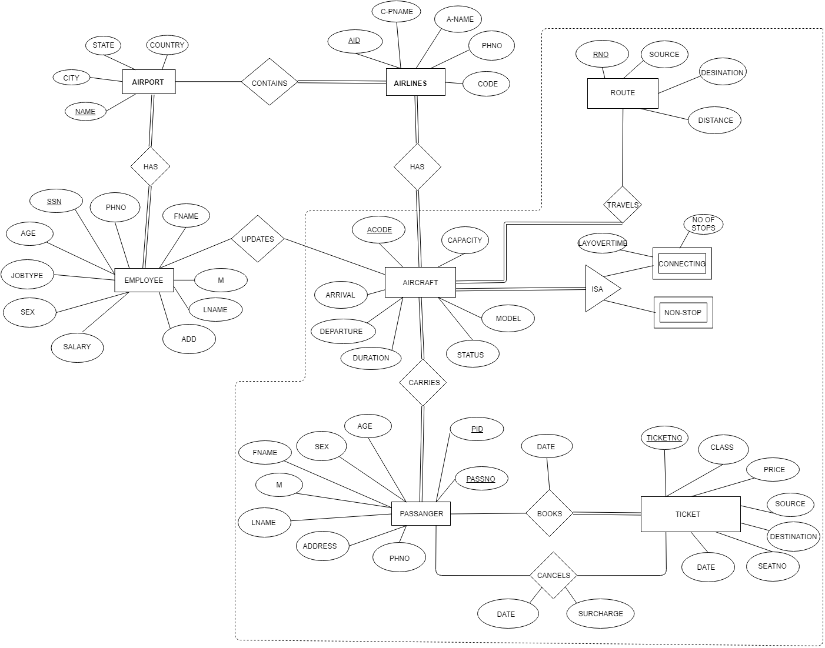

1. ER/EER DIAGRAM

ER diagram contains following relationships:

|  |  |  |  |
| --- | --- | --- | --- |
| Entity 1 | Name of the Relationship | Entity 2 | Cardinality |
| Airport | contains | Airline | m : n |
| Airport | has | Employee | 1 : n |
| Airline | has | Aircraft | 1 : n |
| Aircraft | travels on | Route | m : n |
| Aircraft | carries | Passenger | 1 : n |
| Passenger | books | Ticket | 1 : n |
| Passenger | cancels | Ticket | 1 : n |

1. RELATIONAL SCHEMA

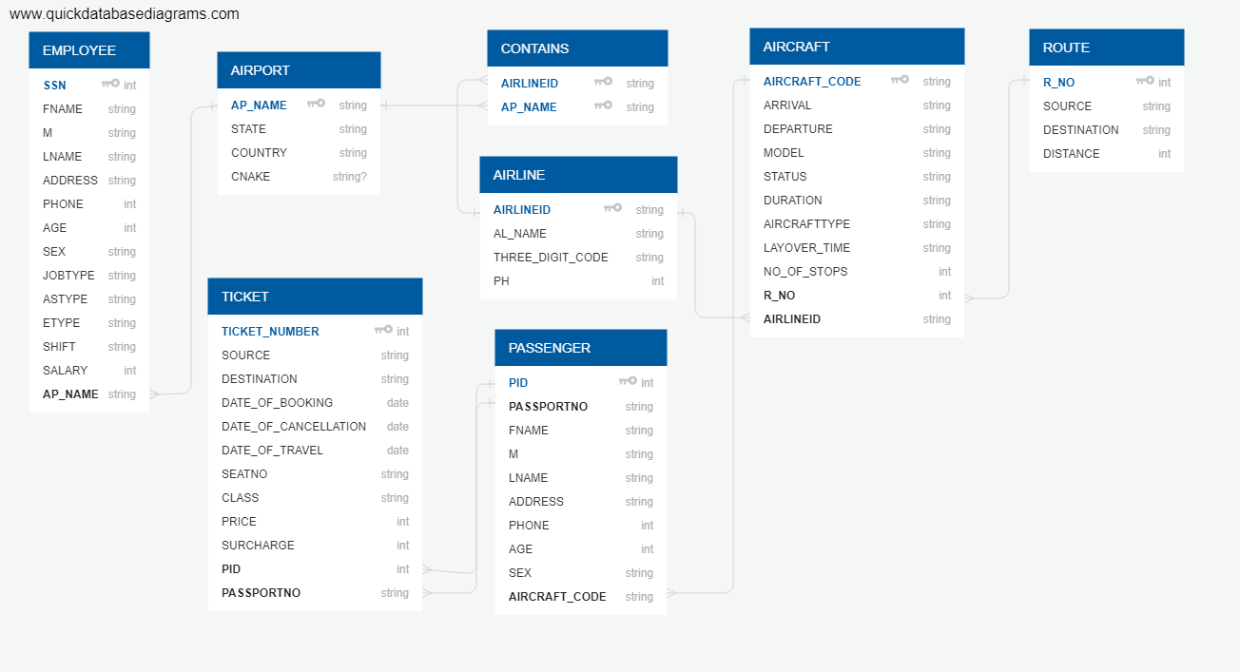

1. NORMALISATION RULES ON DATABASE

|  |  |
| --- | --- |
| FUNCTIONAL DEPENDECIES |  |
| PASSPORTNO -> FNAME, M, LNAME, ADDRESS, PHONE, AGE, SEX | Violates 2NF |
| PID -> FLIGHT_CODE | Violates 2NF |
| DATE_OF_BOOKING, SOURCE, DESTINATION, CLASS -> PRICE | Violates 3NF |
| DATE_OF_CANCELLATION -> SURCHARGE | Violates 3NF |
| JOBTYPE -> SALARY | Violates 3NF |

Normalizing tables into 3NF

|  |
| --- |
| TABLES AFTER NORMALIZATION |
| AIRPORT (AP_NAME, STATE, COUNTRY, CNAME)  AIRLINE (AIRLINEID, AL_NAME, THREE_DIGIT_CODE, PH)  CONTAINS (AIRLINEID, AP_NAME)  AIRCRAFT (AIRCRAFT_CODE, R_NO, ARRIVAL, DEPARTURE, STATUS, DURATION1, AIRCRAFTTYPE, LAYOVER_TIME, NO_OF_STOPS, MODEL, AIRLINEID)  ROUTE (R_NO, SOURCE, DESTINATION, DISTANCE)  PASSENGER1 (PID, PASSPORTNO)  PASSENGER2 (PASSPORTNO, FNAME, M, LNAME, ADDRESS, PHONE, AGE, SEX)  PASSENGER3 (PID, FLIGHT_CODE)  TICKET1 (TICKET_NUMBER, SOURCE1, DESTINATION, DATE_OF_BOOKING, DATE_OF_CANCELLATION, DATE_OF_TRAVEL, SEATNO, CLASS1, PID, PASSPORTNO)  TICKET2 (DATE_OF_BOOKING, SOURCE, DESTINATION, CLASS1, PRICE)  TICKET3 (DATE_OF_CANCELLATION, SURCHARGE)  EMPLOYEE1 (SSN, FNAME, M, LNAME, ADDRESS, PHONE, AGE, SEX, JOBTYPE, ASTYPE, ETYPE, SHIFT,  POSITION, AP_NAME)  EMPLOYEE2 (JOBTYPE, SALARY) |

1. NORMALISED RELATIONAL SCHEMA

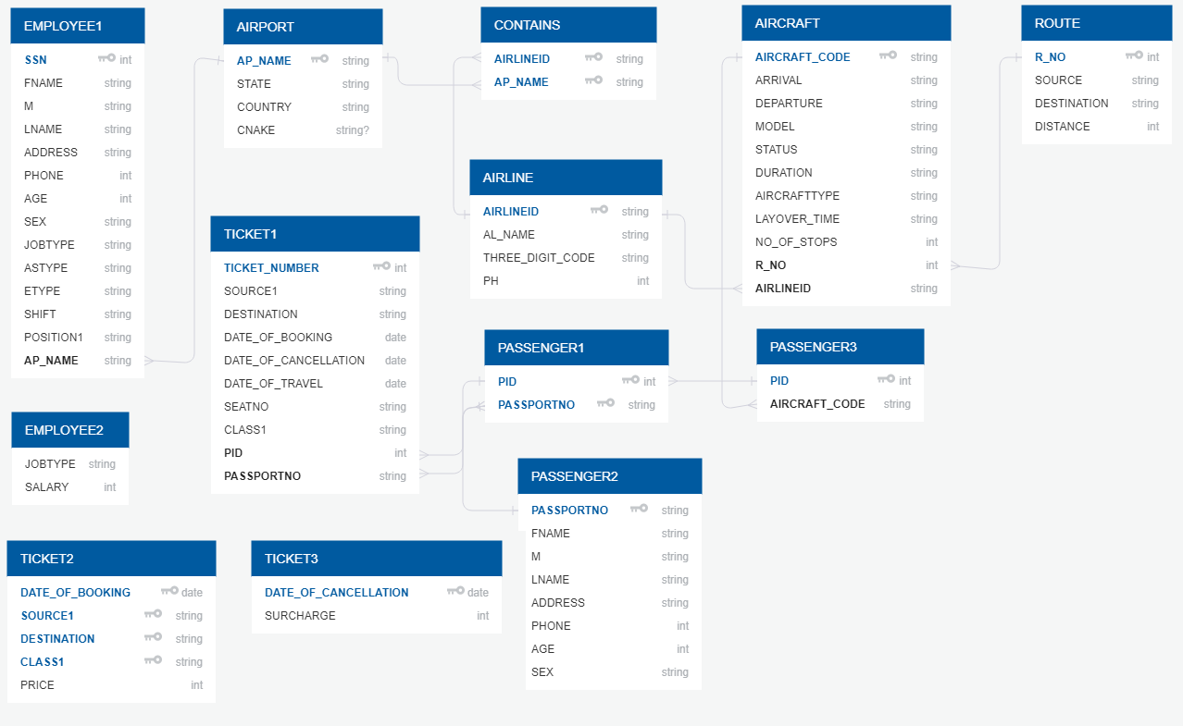

1. SQL

**-- Creating AIRPORT Table --**

CREATE TABLE AIRPORT

(AP_NAME VARCHAR2(100) NOT NULL,

STATE VARCHAR2(15),

COUNTRY VARCHAR(30),

CNAME VARCHAR2(15),

PRIMARY KEY(AP_NAME));

**--Inserting values for Table: AIRPORT--**

INSERT INTO AIRPORT (AP_NAME, STATE, COUNTRY, CNAME) VALUES('Louisville International Airport','Kentucky','United States','Louisville');

INSERT INTO AIRPORT (AP_NAME, STATE, COUNTRY, CNAME) VALUES('Chandigarh International Airport','Chandigarh','India','Chandigarh');

INSERT INTO AIRPORT (AP_NAME, STATE, COUNTRY, CNAME) VALUES('Dallas/Fort Worth International Airport','Texas','United States','Fort Worth');

INSERT INTO AIRPORT (AP_NAME, STATE, COUNTRY, CNAME) VALUES('Indira GandhiInternational Airport','Delhi','India','Delhi');

INSERT INTO AIRPORT (AP_NAME, STATE, COUNTRY, CNAME) VALUES('Chhatrapati Shivaji International Airport','Maharashtra','India','Mumbai');

INSERT INTO AIRPORT (AP_NAME, STATE, COUNTRY, CNAME) VALUES('San Francisco International Airport','California', 'United States','San Francisco');

INSERT INTO AIRPORT (AP_NAME, STATE, COUNTRY, CNAME) VALUES('Frankfurt Airport','Hesse','Germany','Frankfurt');

INSERT INTO AIRPORT (AP_NAME, STATE, COUNTRY, CNAME) VALUES('George Bush Intercontinental Airport','Texas','United States','Houston');

INSERT INTO AIRPORT (AP_NAME, STATE, COUNTRY, CNAME) VALUES('John F. Kennedy International Airport','New York','United States','New York City');

INSERT INTO AIRPORT (AP_NAME, STATE, COUNTRY, CNAME) VALUES('Tampa International Airport','Florida', 'United States','Tampa');

**-- Checking values insertion --**

SELECT *

FROM AIRPORT;

**-- Creating AIRLINE Table --**

CREATE TABLE AIRLINE

(AIRLINEID VARCHAR(3) NOT NULL,

AL_NAME VARCHAR2(50),

THREE_DIGIT_CODE VARCHAR(3),

PH INT,

PRIMARY KEY(AIRLINEID));

**-- Inserting values for Table: AIRLINE --**

INSERT INTO AIRLINE (AIRLINEID, AL_NAME, THREE_DIGIT_CODE, PH) VALUES('AA','American Airlines','001', 1800123456);

INSERT INTO AIRLINE (AIRLINEID, AL_NAME, THREE_DIGIT_CODE, PH) VALUES('AI','Air India Limited','098', 1800234567);

INSERT INTO AIRLINE (AIRLINEID, AL_NAME, THREE_DIGIT_CODE, PH) VALUES('LH','Lufthansa', '220', 1800345678);

INSERT INTO AIRLINE (AIRLINEID, AL_NAME, THREE_DIGIT_CODE, PH) VALUES('BA','British Airways','125', 1800456789);

INSERT INTO AIRLINE (AIRLINEID, AL_NAME, THREE_DIGIT_CODE, PH) VALUES('QR','Qatar Airways','157', 1800987654);

INSERT INTO AIRLINE (AIRLINEID, AL_NAME, THREE_DIGIT_CODE, PH) VALUES('9W','Jet Airways','589', 1800876543);

INSERT INTO AIRLINE (AIRLINEID, AL_NAME, THREE_DIGIT_CODE, PH) VALUES('EK','Emirates','176', 1800765432);

INSERT INTO AIRLINE (AIRLINEID, AL_NAME, THREE_DIGIT_CODE, PH) VALUES('EY','Ethiad Airways','607', 1800654321);

**-- Checking values insertion --**

SELECT *

FROM AIRLINE;

**-- Creating CONTAINS Table --**

CREATE TABLE CONTAINS

(AIRLINEID VARCHAR(3) NOT NULL,

AP_NAME VARCHAR2(100) NOT NULL,

PRIMARY KEY(AIRLINEID, AP_NAME),

FOREIGN KEY(AIRLINEID) REFERENCES AIRLINE(AIRLINEID) ON DELETE CASCADE,

FOREIGN KEY(AP_NAME) REFERENCES AIRPORT(AP_NAME) ON DELETE CASCADE);

**-- Inserting values into Table: CONTAINS--**

INSERT INTO CONTAINS (AIRLINEID, AP_NAME) VALUES('AA','Louisville International Airport');

INSERT INTO CONTAINS (AIRLINEID, AP_NAME) VALUES('AA','John F. Kennedy International Airport');

INSERT INTO CONTAINS (AIRLINEID, AP_NAME) VALUES('AA','George Bush Intercontinental Airport');

INSERT INTO CONTAINS (AIRLINEID, AP_NAME) VALUES('AA','San Francisco International Airport');

INSERT INTO CONTAINS (AIRLINEID, AP_NAME) VALUES('AA','Tampa International Airport');

INSERT INTO CONTAINS (AIRLINEID, AP_NAME) VALUES('AI','Chandigarh International Airport');

INSERT INTO CONTAINS (AIRLINEID, AP_NAME) VALUES('AI','Dallas/Fort Worth International Airport');

INSERT INTO CONTAINS (AIRLINEID, AP_NAME) VALUES('AI','Indira GandhiInternational Airport');

INSERT INTO CONTAINS (AIRLINEID, AP_NAME) VALUES('AI','Chhatrapati Shivaji International Airport');

INSERT INTO CONTAINS (AIRLINEID, AP_NAME) VALUES('AI','George Bush Intercontinental Airport');

INSERT INTO CONTAINS (AIRLINEID, AP_NAME) VALUES('LH','Chhatrapati Shivaji International Airport');

INSERT INTO CONTAINS (AIRLINEID, AP_NAME) VALUES('LH','Frankfurt Airport');

INSERT INTO CONTAINS (AIRLINEID, AP_NAME) VALUES('LH','John F. Kennedy International Airport');

INSERT INTO CONTAINS (AIRLINEID, AP_NAME) VALUES('LH','San Francisco International Airport');

INSERT INTO CONTAINS (AIRLINEID, AP_NAME) VALUES('LH','Dallas/Fort Worth International Airport');

INSERT INTO CONTAINS (AIRLINEID, AP_NAME) VALUES('BA','John F. Kennedy International Airport');

INSERT INTO CONTAINS (AIRLINEID, AP_NAME) VALUES('BA','Chhatrapati Shivaji International Airport');

INSERT INTO CONTAINS (AIRLINEID, AP_NAME) VALUES('BA','Chandigarh International Airport');

INSERT INTO CONTAINS (AIRLINEID, AP_NAME) VALUES('BA','Frankfurt Airport');

INSERT INTO CONTAINS (AIRLINEID, AP_NAME) VALUES('BA','San Francisco International Airport');

INSERT INTO CONTAINS (AIRLINEID, AP_NAME) VALUES('QR','Chhatrapati Shivaji International Airport');

INSERT INTO CONTAINS (AIRLINEID, AP_NAME) VALUES('QR','Dallas/Fort Worth International Airport');

INSERT INTO CONTAINS (AIRLINEID, AP_NAME) VALUES('QR','John F. Kennedy International Airport');

INSERT INTO CONTAINS (AIRLINEID, AP_NAME) VALUES('QR','Tampa International Airport');

INSERT INTO CONTAINS (AIRLINEID, AP_NAME) VALUES('QR','Louisville International Airport');

**-- Checking values insertion --**

SELECT *

FROM CONTAINS;

**-- Creating ROUTE Table --**

CREATE TABLE ROUTE

( R_NO INT,

SOURCE VARCHAR(3),

DESTINATION VARCHAR(3),

DISTANCE INT,

PRIMARY KEY(R_NO));

**-- Inserting values into Table: ROUTE --**

INSERT INTO ROUTE(R_NO, SOURCE, DESTINATION, DISTANCE)

VALUES(001, 'BOM', 'DFW', 11596);

INSERT INTO ROUTE(R_NO, SOURCE, DESTINATION, DISTANCE)

VALUES(002, 'JFK', 'TPA', 1468);

INSERT INTO ROUTE(R_NO, SOURCE, DESTINATION, DISTANCE)

VALUES(003, 'JFK', 'BOM', 14846);

INSERT INTO ROUTE(R_NO, SOURCE, DESTINATION, DISTANCE)

VALUES(004, 'FRA', 'DEL', 12435);

INSERT INTO ROUTE(R_NO, SOURCE, DESTINATION, DISTANCE)

VALUES(005, 'SFO', 'FRA', 17546);

INSERT INTO ROUTE(R_NO, SOURCE, DESTINATION, DISTANCE)

VALUES(006, 'IXC', 'IAH', 17497);

INSERT INTO ROUTE(R_NO, SOURCE, DESTINATION, DISTANCE)

VALUES(007, 'BOM', 'SFO', 19124);

INSERT INTO ROUTE(R_NO, SOURCE, DESTINATION, DISTANCE)

VALUES(008, 'IAH', 'DEL', 16517);

**-- Checking values insertion --**

SELECT *

FROM ROUTE;

**-- Creating AIRCRAFT Table --**

CREATE TABLE AIRCRAFT

(AIRCRAFT_CODE VARCHAR(10) NOT NULL,

ARRIVAL VARCHAR2(10),

DEPARTURE VARCHAR2(10),

MODEL1 VARCHAR(10),

STATUS VARCHAR(10),

DURATION1 VARCHAR2(30),

AIRCRAFTTYPE VARCHAR(10),

LAYOVER_TIME VARCHAR2(30),

NO_OF_STOPS INT,

AIRLINEID VARCHAR(3),

R_NO INT,

PRIMARY KEY(AIRCRAFT_CODE),

FOREIGN KEY(R_NO) REFERENCES ROUTE(R_NO),

FOREIGN KEY(AIRLINEID) REFERENCES AIRLINE(AIRLINEID) ON DELETE CASCADE);

**-- Inserting values into Table: Contains--**

INSERT INTO AIRCRAFT(AIRCRAFT_CODE, R_NO, ARRIVAL, DEPARTURE, STATUS, DURATION1, AIRCRAFTTYPE, LAYOVER_TIME, NO_OF_STOPS, MODEL1, AIRLINEID)

VALUES('AI2014', 001,'02:10','03:15','On-time','24hr','Connecting',3,1,'BOEG-747','AI');

INSERT INTO AIRCRAFT(AIRCRAFT_CODE, R_NO, ARRIVAL, DEPARTURE, STATUS, DURATION1, AIRCRAFTTYPE, LAYOVER_TIME, NO_OF_STOPS, MODEL1, AIRLINEID)

VALUES('QR2305', 001,'13:00','13:55','Delayed','21hr','Non-stop',0,0,'BOEG-777', 'QR');

INSERT INTO AIRCRAFT(AIRCRAFT_CODE, R_NO, ARRIVAL, DEPARTURE, STATUS, DURATION1, AIRCRAFTTYPE, LAYOVER_TIME, NO_OF_STOPS, MODEL1, AIRLINEID)

VALUES('EY1234',002,'19:20','20:05','On-time','16hrs','Connecting',5,2,'BOEG-737','EY');

INSERT INTO AIRCRAFT(AIRCRAFT_CODE, R_NO, ARRIVAL, DEPARTURE, STATUS, DURATION1, AIRCRAFTTYPE, LAYOVER_TIME, NO_OF_STOPS, MODEL1, AIRLINEID)

VALUES('LH9876',003,'05:50','06:35','On-time','18hrs','Non-stop',0,0,'BOEG-757','LH');

INSERT INTO AIRCRAFT(AIRCRAFT_CODE, R_NO, ARRIVAL, DEPARTURE, STATUS, DURATION1, AIRCRAFTTYPE, LAYOVER_TIME, NO_OF_STOPS, MODEL1, AIRLINEID)

VALUES('BA1689',004,'10:20','10:55','On-time','14hrs','Non-stop',0,0,'BOEG-757','BA');

INSERT INTO AIRCRAFT(AIRCRAFT_CODE, R_NO, ARRIVAL, DEPARTURE, STATUS, DURATION1, AIRCRAFTTYPE, LAYOVER_TIME, NO_OF_STOPS, MODEL1, AIRLINEID)

VALUES('AA4367',005,'18:10','18:55','On-time','21hrs','Non-stop',0,0,'BOEG-777','AA');

INSERT INTO AIRCRAFT(AIRCRAFT_CODE, R_NO, ARRIVAL, DEPARTURE, STATUS, DURATION1, AIRCRAFTTYPE, LAYOVER_TIME, NO_OF_STOPS, MODEL1, AIRLINEID)

VALUES('QR1902',006,'22:00','22:50','Delayed','28hrs','Non-stop',5,1,'BOEG-737','QR');

INSERT INTO AIRCRAFT(AIRCRAFT_CODE, R_NO, ARRIVAL, DEPARTURE, STATUS, DURATION1, AIRCRAFTTYPE, LAYOVER_TIME, NO_OF_STOPS, MODEL1, AIRLINEID)

VALUES('BA3056',001,'02:15','02:55','On-time','29hrs','Connecting',3,1,'BOEG-747','BA');

INSERT INTO AIRCRAFT(AIRCRAFT_CODE, R_NO, ARRIVAL, DEPARTURE, STATUS, DURATION1, AIRCRAFTTYPE, LAYOVER_TIME, NO_OF_STOPS, MODEL1, AIRLINEID)

VALUES('EK3456',007,'18:50','19:40','On-time','30hrs','Non-stop',0,0,'BOEG-777','EK');

INSERT INTO AIRCRAFT(AIRCRAFT_CODE, R_NO, ARRIVAL, DEPARTURE, STATUS, DURATION1, AIRCRAFTTYPE, LAYOVER_TIME, NO_OF_STOPS, MODEL1, AIRLINEID)

VALUES('9W2334',008,'23:00','13:45','On-time','23hrs','Direct',0,0,'BOEG-747','9W');

**-- Checking values insertion --**

SELECT *

FROM AIRCRAFT;

*SELECT \**

*FROM AIRCRAFT*

*FULL OUTER JOIN ROUTE ON AIRCRAFT.R_NO = ROUTE.R_NO;*

**-- Creating PASSENGER1 Table --**

CREATE TABLE PASSENGER1

(PID INT NOT NULL,

PASSPORTNO VARCHAR(10) NOT NULL,

PRIMARY KEY(PID, PASSPORTNO));

**-- Inserting values in table: PASSENGER1--**

INSERT INTO PASSENGER1(PID, PASSPORTNO) VALUES(1,'A1234568');

INSERT INTO PASSENGER1(PID, PASSPORTNO) VALUES(2,'B9876541');

INSERT INTO PASSENGER1(PID, PASSPORTNO) VALUES(3,'C2345698');

INSERT INTO PASSENGER1(PID, PASSPORTNO) VALUES(4,'D1002004');

INSERT INTO PASSENGER1(PID, PASSPORTNO) VALUES(5,'X9324666');

INSERT INTO PASSENGER1(PID, PASSPORTNO) VALUES(6,'B8765430');

INSERT INTO PASSENGER1(PID, PASSPORTNO) VALUES(7,'J9801235');

INSERT INTO PASSENGER1(PID, PASSPORTNO) VALUES(8,'A1122334');

INSERT INTO PASSENGER1(PID, PASSPORTNO) VALUES(9,'Q1243567');

INSERT INTO PASSENGER1(PID, PASSPORTNO) VALUES(10,'S1243269');

INSERT INTO PASSENGER1(PID, PASSPORTNO) VALUES(11,'E3277889');

INSERT INTO PASSENGER1(PID, PASSPORTNO) VALUES(12,'K3212322');

INSERT INTO PASSENGER1(PID, PASSPORTNO) VALUES(13,'P3452390');

INSERT INTO PASSENGER1(PID, PASSPORTNO) VALUES(14,'W7543336');

INSERT INTO PASSENGER1(PID, PASSPORTNO) VALUES(15,'R8990566');

**-- Checking values insertion --**

SELECT *

FROM PASSENGER1;

**-- Creating PASSENGER2 Table --**

CREATE TABLE PASSENGER2

(PASSPORTNO VARCHAR(10) NOT NULL,

FNAME VARCHAR2(20),

M VARCHAR(1),

LNAME VARCHAR2(20),

ADDRESS VARCHAR2(100),

PHONE INT,

AGE INT,

SEX VARCHAR(1),

PRIMARY KEY(PASSPORTNO));

**--Inserting values in table: PASSENGER2--**

INSERT INTO PASSENGER2(PASSPORTNO,FNAME,M,LNAME,ADDRESS,PHONE,AGE,SEX)

VALUES('A1234568','ALEN','M','SMITH','2230 NORTHSIDE, APT 11, ALBANY, NY',8080367290,30,'M');

INSERT INTO PASSENGER2(PASSPORTNO,FNAME,M,LNAME,ADDRESS,PHONE,AGE,SEX)

VALUES('B9876541','ANKITA','V','AHIR','3456 VIKAS APTS, APT 102,DOMBIVLI, INDIA',8080367280,26,'F');

INSERT INTO PASSENGER2(PASSPORTNO,FNAME,M,LNAME,ADDRESS,PHONE,AGE,SEX)

VALUES('C2345698','KHYATI','A','MISHRA','7820 MCCALLUM COURTS, APT 234, AKRON, OH',8082267280,30,'F');

INSERT INTO PASSENGER2(PASSPORTNO,FNAME,M,LNAME,ADDRESS,PHONE,AGE,SEX)

VALUES('D1002004','ANKITA','S','PATIL','7720 MCCALLUM BLVD, APT 1082, DALLAS, TX',9080367266,23,'F');

INSERT INTO PASSENGER2(PASSPORTNO,FNAME,M,LNAME,ADDRESS,PHONE,AGE,SEX)

VALUES('X9324666','TEJASHREE','B','PANDIT','9082 ESTAES OF RICHARDSON, RICHARDSON, TX',9004360125,28,'F');

INSERT INTO PASSENGER2(PASSPORTNO,FNAME,M,LNAME,ADDRESS,PHONE,AGE,SEX)

VALUES('B8765430','LAKSHMI','P','SHARMA','1110 FIR HILLS, APT 903, AKRON, OH',7666190505,30,'F');

INSERT INTO PASSENGER2(PASSPORTNO,FNAME,M,LNAME,ADDRESS,PHONE,AGE,SEX)

VALUES('J9801235','AKHILESH','D','JOSHI','345 CHATHAM COURTS, APT 678, MUMBAI, INDIA',9080369290,29,'M');

INSERT INTO PASSENGER2(PASSPORTNO,FNAME,M,LNAME,ADDRESS,PHONE,AGE,SEX)

VALUES('A1122334','MANAN','S','LAKHANI','5589 CHTHAM REFLECTIONS, APT 349 HOUSTON, TX',9004335126,25,'F');

INSERT INTO PASSENGER2(PASSPORTNO,FNAME,M,LNAME,ADDRESS,PHONE,AGE,SEX)

VALUES('Q1243567','KARAN','M','MOTANI','4444 FRANKFORD VILLA, APT 77, GUILDERLAND, NY',9727626643,22,'M');

INSERT INTO PASSENGER2(PASSPORTNO,FNAME,M,LNAME,ADDRESS,PHONE,AGE,SEX)

VALUES('S1243269','ROM','A','SOLANKI','7720 MCCALLUM BLVD, APT 2087, DALLAS, TX',9004568903,60,'M');

INSERT INTO PASSENGER2(PASSPORTNO,FNAME,M,LNAME,ADDRESS,PHONE,AGE,SEX)

VALUES('E3277889','John','A','GATES','1234 BAKER APTS, APT 59, HESSE, GERMANY',9724569986,10,'M');

INSERT INTO PASSENGER2(PASSPORTNO,FNAME,M,LNAME,ADDRESS,PHONE,AGE,SEX)

VALUES('K3212322','SARA','B','GOMES','6785 SPLITSVILLA, APT 34, MIAMI, FL',9024569226,15,'F');

INSERT INTO PASSENGER2(PASSPORTNO,FNAME,M,LNAME,ADDRESS,PHONE,AGE,SEX)

VALUES('P3452390','ALIA','V','BHAT','548 MARKET PLACE, SAN Francisco, CA',9734567800,10,'F');

INSERT INTO PASSENGER2(PASSPORTNO,FNAME,M,LNAME,ADDRESS,PHONE,AGE,SEX)

VALUES('W7543336','JOHN','P','SMITH','6666 ROCK HILL, APT 2902, TAMPA, FL',4624569986,55,'M');

INSERT INTO PASSENGER2(PASSPORTNO,FNAME,M,LNAME,ADDRESS,PHONE,AGE,SEX)

VALUES('R8990566','RIA','T','GUPTA','3355 PALENCIA, APT 2065, MUMBAI, INDIA',4724512343,10,'M');

**-- Checking values insertion --**

SELECT *

FROM PASSENGER2;

**-- Creating PASSENGER3 Table --**

CREATE TABLE PASSENGER3

(PID INT NOT NULL,

AIRCRAFT_CODE VARCHAR(10),

PRIMARY KEY(PID),

FOREIGN KEY(AIRCRAFT_CODE) REFERENCES AIRCRAFT(AIRCRAFT_CODE) ON DELETE CASCADE);

**-- Inserting values into table: PASSENGER3--**

INSERT INTO PASSENGER3(PID, AIRCRAFT_CODE) VALUES(1,'AI2014');

INSERT INTO PASSENGER3(PID, AIRCRAFT_CODE) VALUES(2,'LH9876');

INSERT INTO PASSENGER3(PID, AIRCRAFT_CODE) VALUES(3,'9W2334');

INSERT INTO PASSENGER3(PID, AIRCRAFT_CODE) VALUES(4,'QR1902');

INSERT INTO PASSENGER3(PID, AIRCRAFT_CODE) VALUES(5,'EY1234');

INSERT INTO PASSENGER3(PID, AIRCRAFT_CODE) VALUES(6,'BA3056');

INSERT INTO PASSENGER3(PID, AIRCRAFT_CODE) VALUES(7,'9W2334');

INSERT INTO PASSENGER3(PID, AIRCRAFT_CODE) VALUES(8,'AA4367');

INSERT INTO PASSENGER3(PID, AIRCRAFT_CODE) VALUES(9,'QR1902');

INSERT INTO PASSENGER3(PID, AIRCRAFT_CODE) VALUES(10,'EK3456');

INSERT INTO PASSENGER3(PID, AIRCRAFT_CODE) VALUES(11,'BA1689');

INSERT INTO PASSENGER3(PID, AIRCRAFT_CODE) VALUES(12,'QR1902');

INSERT INTO PASSENGER3(PID, AIRCRAFT_CODE) VALUES(13,'AI2014');

INSERT INTO PASSENGER3(PID, AIRCRAFT_CODE) VALUES(14,'BA1689');

INSERT INTO PASSENGER3(PID, AIRCRAFT_CODE) VALUES(15,'QR2305');

**-- Checking values insertion --**

SELECT *

FROM PASSENGER3;

**-- Creating EMPLOYEE1 Table --**

CREATE TABLE EMPLOYEE1

(SSN INT NOT NULL,

FNAME VARCHAR2(20),

M VARCHAR(1),

LNAME VARCHAR2(20),

ADDRESS VARCHAR2(100),

PHONE INT,

AGE INT,

SEX VARCHAR(1),

JOBTYPE VARCHAR2(30),

ASTYPE VARCHAR2(30),

ETYPE VARCHAR2(30),

SHIFT VARCHAR2(20),

POSITION1 VARCHAR2(30),

AP_NAME VARCHAR2(100),

CONSTRAINT check_emp_age

CHECK (AGE < 60),

PRIMARY KEY(SSN),

FOREIGN KEY(AP_NAME) REFERENCES AIRPORT(AP_NAME) ON DELETE CASCADE);

**-- Inserting values into table: EMPLOYEE1--**

INSERT INTO EMPLOYEE1(SSN, FNAME, M, LNAME, ADDRESS, PHONE, AGE, SEX, JOBTYPE, ASTYPE, ETYPE, SHIFT, POSITION1, AP_NAME)

VALUES(123456789,'LINDA','M','GOODMAN','731 Fondren, Houston, TX',4356789345, 35, 'F','ADMINISTRATIVE SUPPORT','RECEPTIONIST','','','','Louisville International Airport');

INSERT INTO EMPLOYEE1(SSN, FNAME, M, LNAME, ADDRESS, PHONE, AGE, SEX, JOBTYPE, ASTYPE, ETYPE, SHIFT, POSITION1, AP_NAME)

VALUES(333445555,'JOHNY','N','PAUL','638 Voss, Houston, TX',9834561995, 40, 'M','ADMINISTRATIVE SUPPORT','SECRETARY','','','','Louisville International Airport');

INSERT INTO EMPLOYEE1(SSN, FNAME, M, LNAME, ADDRESS, PHONE, AGE, SEX, JOBTYPE, ASTYPE, ETYPE, SHIFT, POSITION1, AP_NAME)

VALUES(999887777,'JAMES','P','BOND','3321 Castle, Spring, TX',9834666995, 50, 'M','ENGINEER','','RADIO ENGINEER','','','Louisville International Airport');

INSERT INTO EMPLOYEE1(SSN, FNAME, M, LNAME, ADDRESS, PHONE, AGE, SEX, JOBTYPE, ASTYPE, ETYPE, SHIFT, POSITION1, AP_NAME)

VALUES(987654321,'SHERLOCK','A','HOLMES','123 TOP HILL, SAN Francisco,CA',8089654321, 47, 'M','TRAFFIC MONITOR','','','DAY','','San Francisco International Airport');

INSERT INTO EMPLOYEE1(SSN, FNAME, M, LNAME, ADDRESS, PHONE, AGE, SEX, JOBTYPE, ASTYPE, ETYPE, SHIFT, POSITION1, AP_NAME)

VALUES(666884444,'SHELDON','A','COOPER','345 CHERRY PARK, HESSE,GERMANY',1254678903, 55, 'M','TRAFFIC MONITOR','','NIGHT','','','Frankfurt Airport');

INSERT INTO EMPLOYEE1(SSN, FNAME, M, LNAME, ADDRESS, PHONE, AGE, SEX, JOBTYPE, ASTYPE, ETYPE, SHIFT, POSITION1, AP_NAME)

VALUES(453453453,'RAJ','B','SHARMA','345 FLOYDS, MUMBAI,INDIA',4326789031, 35, 'M','AIRPORT AUTHORITY','','','','MANAGER','Chhatrapati Shivaji International Airport');

INSERT INTO EMPLOYEE1(SSN, FNAME, M, LNAME, ADDRESS, PHONE, AGE, SEX, JOBTYPE, ASTYPE, ETYPE, SHIFT, POSITION1, AP_NAME)

VALUES(987987987,'NIKITA','C','PAUL','110 SYNERGY PARK, DALLAS,TX',5678904325, 33, 'F','ENGINEER','','AIRPORT CIVIL ENGINEER','','','Dallas/Fort Worth International Airport');

INSERT INTO EMPLOYEE1(SSN, FNAME, M, LNAME, ADDRESS, PHONE, AGE, SEX, JOBTYPE, ASTYPE, ETYPE, SHIFT, POSITION1, AP_NAME)

VALUES(888665555,'SHUBHAM','R','GUPTA','567 CHANDANI CHOWK, DELHI, INDIA',8566778890, 39, 'M','ADMINISTRATIVE SUPPORT','DATA ENTRY WORKER','','','','Indira GandhiInternational Airport');

INSERT INTO EMPLOYEE1(SSN, FNAME, M, LNAME, ADDRESS, PHONE, AGE, SEX, JOBTYPE, ASTYPE, ETYPE, SHIFT, POSITION1, AP_NAME)

VALUES(125478909,'PRATIK','T','GOMES','334 VITRUVIAN PARK, ALBANY, NY',4444678903, 56, 'M','TRAFFIC MONITOR','','DAY','','','John F. Kennedy International Airport');

INSERT INTO EMPLOYEE1(SSN, FNAME, M, LNAME, ADDRESS, PHONE, AGE, SEX, JOBTYPE, ASTYPE, ETYPE, SHIFT, POSITION1, AP_NAME)

VALUES(324567897,'ADIT','P','DESAI','987 SOMNATH, CHANDIGARH, INDIA',2244658909, 36, 'M','TRAFFIC MONITOR','','DAY','','','Chandigarh International Airport');

**-- Checking values insertion --**

SELECT *

FROM EMPLOYEE1;

**-- Creating EMPLOYEE2 Table --**

CREATE TABLE EMPLOYEE2

(JOBTYPE VARCHAR2(30) NOT NULL,

SALARY INT,

PRIMARY KEY(JOBTYPE));

**-- Inserting values into table: EMPLOYEE2 --**

INSERT INTO EMPLOYEE2(JOBTYPE, SALARY)VALUES('ADMINISTRATIVE SUPPORT',50000);

INSERT INTO EMPLOYEE2(JOBTYPE, SALARY)VALUES('ENGINEER',70000);

INSERT INTO EMPLOYEE2(JOBTYPE, SALARY)VALUES('TRAFFIC MONITOR',80000);

INSERT INTO EMPLOYEE2(JOBTYPE, SALARY)VALUES('AIRPORT AUTHORITY',90000);

**-- Checking values insertion --**

SELECT *

FROM EMPLOYEE2;

**-- Creating TICKET1 Table --**

CREATE TABLE TICKET1

(TICKET_NUMBER INT NOT NULL,

SOURCE1 VARCHAR(3),

DESTINATION VARCHAR(3),

DATE_OF_BOOKING DATE,

DATE_OF_TRAVEL DATE,

SEATNO VARCHAR(5),

CLASS1 VARCHAR2(15),

DATE_OF_CANCELLATION DATE,

PID INT,

PASSPORTNO VARCHAR(10),

FOREIGN KEY(PID, PASSPORTNO) REFERENCES PASSENGER1(PID, PASSPORTNO) ON DELETE CASCADE);

**-- Inserting into table: TICKET1 --**

INSERT INTO TICKET1(TICKET_NUMBER, SOURCE1, DESTINATION, DATE_OF_BOOKING, DATE_OF_CANCELLATION, DATE_OF_TRAVEL, SEATNO, CLASS1, PID, PASSPORTNO)

VALUES(0011234111122,'BOM','DFW','11-MAY-16','','15-DEC-16','32A','ECONOMY',1,'A1234568');

INSERT INTO TICKET1(TICKET_NUMBER, SOURCE1, DESTINATION, DATE_OF_BOOKING, DATE_OF_CANCELLATION, DATE_OF_TRAVEL, SEATNO, CLASS1, PID, PASSPORTNO)

VALUES(0984567222299,'JFK','BOM','11-JUN-16','10-DEC-16','20-DEC-16','45D','ECONOMY',2,'B9876541');

INSERT INTO TICKET1(TICKET_NUMBER, SOURCE1, DESTINATION, DATE_OF_BOOKING, DATE_OF_CANCELLATION, DATE_OF_TRAVEL, SEATNO, CLASS1, PID, PASSPORTNO)

VALUES(1768901333273,'IAH','DEL','21-AUG-16','','25-DEC-16','1A','BUSINESS',3,'C2345698');

INSERT INTO TICKET1(TICKET_NUMBER, SOURCE1, DESTINATION, DATE_OF_BOOKING, DATE_OF_CANCELLATION, DATE_OF_TRAVEL, SEATNO, CLASS1, PID, PASSPORTNO)

VALUES(5890987441464,'IXC','IAH','10-AUG-16','','12-JAN-17','20C','FIRST-CLASS',4,'D1002004');

INSERT INTO TICKET1(TICKET_NUMBER, SOURCE1, DESTINATION, DATE_OF_BOOKING, DATE_OF_CANCELLATION, DATE_OF_TRAVEL, SEATNO, CLASS1, PID, PASSPORTNO)

VALUES(1577654664266,'JFK','TPA','13-JUN-16','','10-DEC-16','54E','ECONOMY',5,'X9324666');

INSERT INTO TICKET1(TICKET_NUMBER, SOURCE1, DESTINATION, DATE_OF_BOOKING, DATE_OF_CANCELLATION, DATE_OF_TRAVEL, SEATNO, CLASS1, PID, PASSPORTNO)

VALUES(2206543545545,'BOM','DFW','11-NOV-16','','12-FEB-17','43B','ECONOMY',6,'B8765430');

INSERT INTO TICKET1(TICKET_NUMBER, SOURCE1, DESTINATION, DATE_OF_BOOKING, DATE_OF_CANCELLATION, DATE_OF_TRAVEL, SEATNO, CLASS1, PID, PASSPORTNO)

VALUES(7064321779737,'IAH','DEL','15-NOV-16','','25-DEC-16','27B','FIRST-CLASS',7,'J9801235');

INSERT INTO TICKET1(TICKET_NUMBER, SOURCE1, DESTINATION, DATE_OF_BOOKING, DATE_OF_CANCELLATION, DATE_OF_TRAVEL, SEATNO, CLASS1, PID, PASSPORTNO)

VALUES(1571357215116,'SFO','FRA','15-OCT-16','','18-DEC-16','34E','ECONOMY',8,'A1122334');

INSERT INTO TICKET1(TICKET_NUMBER, SOURCE1, DESTINATION, DATE_OF_BOOKING, DATE_OF_CANCELLATION, DATE_OF_TRAVEL, SEATNO, CLASS1, PID, PASSPORTNO)

VALUES(1570864987655,'IXC','IAH','12-NOV-16','','30-DEC-16','54C','ECONOMY',9,'Q1243567');

INSERT INTO TICKET1(TICKET_NUMBER, SOURCE1, DESTINATION, DATE_OF_BOOKING, DATE_OF_CANCELLATION, DATE_OF_TRAVEL, SEATNO, CLASS1, PID, PASSPORTNO)

VALUES(1579283997799,'BOM','SFO','22-JAN-16','','15-DEC-16','38A','ECONOMY',10,'S1243269');

INSERT INTO TICKET1(TICKET_NUMBER, SOURCE1, DESTINATION, DATE_OF_BOOKING, DATE_OF_CANCELLATION, DATE_OF_TRAVEL, SEATNO, CLASS1, PID, PASSPORTNO)

VALUES(1255701876107,'FRA','DEL','19-OCT-16','','31-DEC-16','57F','ECONOMY',11,'E3277889');

INSERT INTO TICKET1(TICKET_NUMBER, SOURCE1, DESTINATION, DATE_OF_BOOKING, DATE_OF_CANCELLATION, DATE_OF_TRAVEL, SEATNO, CLASS1, PID, PASSPORTNO)

VALUES(1251334499699,'IXC','IAH','20-NOV-16','','12-JAN-17','45D','ECONOMY',12,'K3212322');

INSERT INTO TICKET1(TICKET_NUMBER, SOURCE1, DESTINATION, DATE_OF_BOOKING, DATE_OF_CANCELLATION, DATE_OF_TRAVEL, SEATNO, CLASS1, PID, PASSPORTNO)

VALUES(1258776199490,'BOM','DFW','13-MAY-16','25-MAY-16','15-DEC-16','37C','ECONOMY',13,'P3452390');

INSERT INTO TICKET1(TICKET_NUMBER, SOURCE1, DESTINATION, DATE_OF_BOOKING, DATE_OF_CANCELLATION, DATE_OF_TRAVEL, SEATNO, CLASS1, PID, PASSPORTNO)

VALUES(5891155114477,'FRA','DEL','26-JUN-16','','23-DEC-16','55C','ECONOMY',14,'W7543336');

INSERT INTO TICKET1(TICKET_NUMBER, SOURCE1, DESTINATION, DATE_OF_BOOKING, DATE_OF_CANCELLATION, DATE_OF_TRAVEL, SEATNO, CLASS1, PID, PASSPORTNO)

VALUES(5893069766787,'BOM','DFW','11-AUG-16','','22-DEC-16','33F','ECONOMY',15,'R8990566');

**-- Checking values insertion --**

SELECT *

FROM TICKET1;

**-- Creating TICKET2 Table --**

CREATE TABLE TICKET2

(DATE_OF_BOOKING DATE NOT NULL,

SOURCE1 VARCHAR(3) NOT NULL,

DESTINATION VARCHAR(3) NOT NULL,

CLASS1 VARCHAR2(15) NOT NULL,

PRICE INT,

PRIMARY KEY(DATE_OF_BOOKING, SOURCE1, DESTINATION, CLASS1));

**-- Inserting values into table: TICKET2 --**

INSERT INTO TICKET2(DATE_OF_BOOKING, SOURCE1, DESTINATION, CLASS1, PRICE)

VALUES('11-MAY-16','BOM','DFW','ECONOMY',95000);

INSERT INTO TICKET2(DATE_OF_BOOKING, SOURCE1, DESTINATION, CLASS1, PRICE)

VALUES('11-JUN-16','JFK','BOM','ECONOMY',100000);

INSERT INTO TICKET2(DATE_OF_BOOKING, SOURCE1, DESTINATION, CLASS1, PRICE)

VALUES('21-AUG-16','IAH','DEL','BUSINESS',200000);

INSERT INTO TICKET2(DATE_OF_BOOKING, SOURCE1, DESTINATION, CLASS1, PRICE)

VALUES('10-AUG-16','IXC','IAH','FIRST-CLASS',150000);

INSERT INTO TICKET2(DATE_OF_BOOKING, SOURCE1, DESTINATION, CLASS1, PRICE)

VALUES('13-JUN-16','JFK','TPA','ECONOMY',98000);

INSERT INTO TICKET2(DATE_OF_BOOKING, SOURCE1, DESTINATION, CLASS1, PRICE)

VALUES('11-NOV-16','BOM','DFW','ECONOMY',125000);

INSERT INTO TICKET2(DATE_OF_BOOKING, SOURCE1, DESTINATION, CLASS1, PRICE)

VALUES('15-NOV-16','IAH','DEL','FIRST-CLASS',195000);

INSERT INTO TICKET2(DATE_OF_BOOKING, SOURCE1, DESTINATION, CLASS1, PRICE)

VALUES('15-OCT-16','SFO','FRA','ECONOMY',170000);

INSERT INTO TICKET2(DATE_OF_BOOKING, SOURCE1, DESTINATION, CLASS1, PRICE)

VALUES('12-NOV-16','IXC','IAH','ECONOMY',140000);

INSERT INTO TICKET2(DATE_OF_BOOKING, SOURCE1, DESTINATION, CLASS1, PRICE)

VALUES('22-JAN-16','BOM','SFO','ECONOMY',45000);

INSERT INTO TICKET2(DATE_OF_BOOKING, SOURCE1, DESTINATION, CLASS1, PRICE)

VALUES('19-OCT-16','FRA','DEL','ECONOMY',100000);

INSERT INTO TICKET2(DATE_OF_BOOKING, SOURCE1, DESTINATION, CLASS1, PRICE)

VALUES('20-NOV-16','IXC','IAH','ECONOMY',120000);

INSERT INTO TICKET2(DATE_OF_BOOKING, SOURCE1, DESTINATION, CLASS1, PRICE)

VALUES('13-MAY-16','BOM','DFW','ECONOMY',65000);

INSERT INTO TICKET2(DATE_OF_BOOKING, SOURCE1, DESTINATION, CLASS1, PRICE)

VALUES('26-JUN-16','FRA','DEL','ECONOMY',80000);

INSERT INTO TICKET2(DATE_OF_BOOKING, SOURCE1, DESTINATION, CLASS1, PRICE)

VALUES('11-AUG-16','BOM','DFW','ECONOMY',98000);

**-- Checking values insertion --**

SELECT *

FROM TICKET2;

**-- Creating TICKET3 Table --**

CREATE TABLE TICKET3

(DATE_OF_CANCELLATION DATE NOT NULL,

SURCHARGE INT,

PRIMARY KEY(DATE_OF_CANCELLATION));

**-- Inserting values into table: TICKET3 --**

INSERT INTO TICKET3(DATE_OF_CANCELLATION, SURCHARGE) VALUES('10-DEC-16',75000);

INSERT INTO TICKET3(DATE_OF_CANCELLATION, SURCHARGE) VALUES('25-MAY-16',25000);

**-- Checking values insertion --**

SELECT *

FROM TICKET3;

1. STORED PROCEDURE
   1. **For details of economy class passengers with destination ‘DFW’**

CREATE OR REPLACE PROCEDURE DFWECONOMYPASSENGERS AS

CURSOR ECOPASSDETAILS is

select al.AL_NAME,fl.AIRCRAFT_CODE,p2.FNAME,p2.LNAME,p2.PASSPORTNO,t.CLASS1,t.DATE_OF_TRAVEL,t.DESTINATION,t.SOURCE1,t.SEATNO,t.TICKET_NUMBER

from Airline al,AIRCRAFT fl,PASSENGER1 p1, PASSENGER2 p2 ,PASSENGER3 p3,TICKET1 t

where al.AIRLINEID = fl.AIRLINEID

and p1.PID= p3.PID

and p1.PASSPORTNO =p2.PASSPORTNO

and fl.AIRCRAFT_CODE = p3.AIRCRAFT_CODE

and t.PASSPORTNO = p2.PASSPORTNO

and t.CLASS1='ECONOMY' and t.DESTINATION='DFW';

PASSDETAILS ECOPASSDETAILS%rowtype;

BEGIN

Open ECOPASSDETAILS ;

LOOP

fetch ECOPASSDETAILS into PASSDETAILS;

EXIT WHEN ECOPASSDETAILS%NOTFOUND;

dbms_output.put_line (PASSDETAILS.AL_NAME || ' ' || PASSDETAILS.AIRCRAFT_CODE || ' ' || PASSDETAILS.FNAME || ' ' || PASSDETAILS.LNAME|| ' ' ||PASSDETAILS.PASSPORTNO || ' ' || PASSDETAILS.CLASS1 || ' ' || PASSDETAILS.SOURCE1 || ' ' || PASSDETAILS.SEATNO || ' ' || PASSDETAILS.TICKET_NUMBER);

END LOOP;

close ECOPASSDETAILS;

END DFWECONOMYPASSENGERS;

/

**--Testing Procedure Output --**

SET SERVEROUTPUT ON

exec DFWECONOMYPASSENGERS();

/

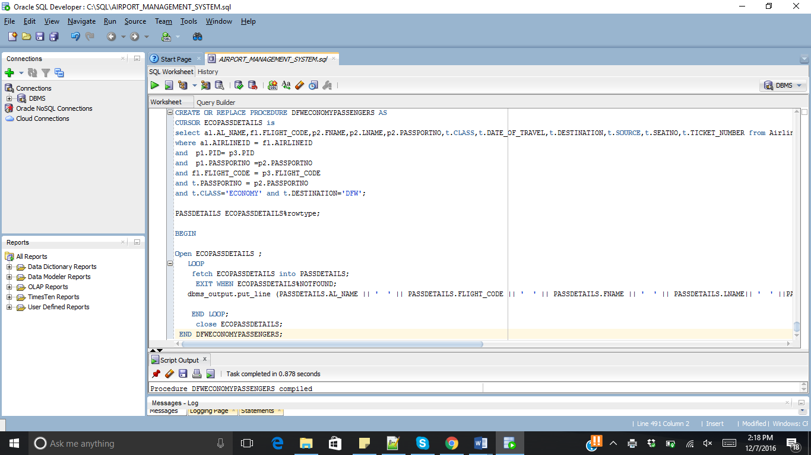

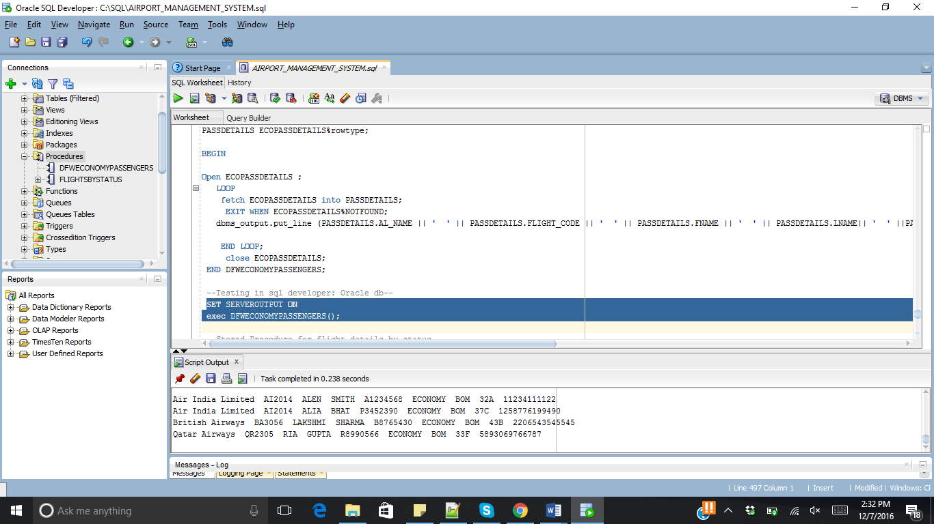

* 1. **Stored Procedure for flight details by status**

CREATE OR REPLACE PROCEDURE AIRCRAFTSBYSTATUS

(

IN_STATUS IN VARCHAR2

) AS

CURSOR fSTATUS is

select distinct f1.AIRCRAFT_CODE ,al.AL_NAME ,f1.ARRIVAL,f1.departure,r1.SOURCE,r1.DESTINATION,f1.STATUS,f1.AIRCRAFTTYPE

from Airline al ,Airport ap1,AIRCRAFT f1, ROUTE r1

where al.AIRLINEID=f1.AIRLINEID and f1.R_NO = r1.R_NO

and f1.STATUS =IN_STATUS;

AIRCRAFTStatus fSTATUS%rowtype;

BEGIN

Open fSTATUS ;

LOOP

fetch fSTATUS into AIRCRAFTStatus;

EXIT WHEN fSTATUS%NOTFOUND;

dbms_output.put_line (AIRCRAFTStatus.AIRCRAFT_CODE || ' ' || AIRCRAFTStatus.AL_NAME || ' ' || AIRCRAFTStatus.ARRIVAL || ' ' || AIRCRAFTStatus.departure|| ' ' ||AIRCRAFTStatus.Source || ' ' || AIRCRAFTStatus.DESTINATION || ' ' || AIRCRAFTStatus.STATUS || ' ' || AIRCRAFTStatus.AIRCRAFTTYPE);

END LOOP;

close fSTATUS;

END AIRCRAFTSBYSTATUS;

/

--Testing output --

SET SERVEROUTPUT ON

exec AIRCRAFTSBYSTATUS('Delayed');

-- or--

SET SERVEROUTPUT ON

exec AIRCRAFTSBYSTATUS('On-time');

/

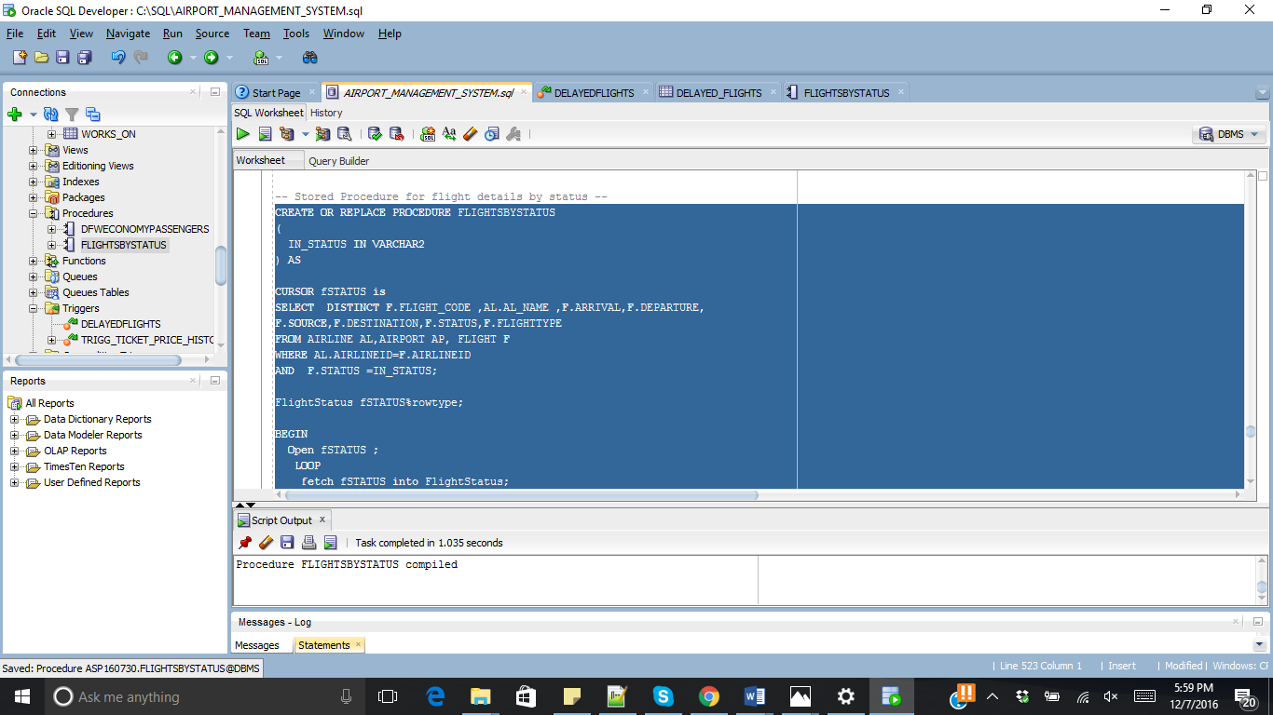

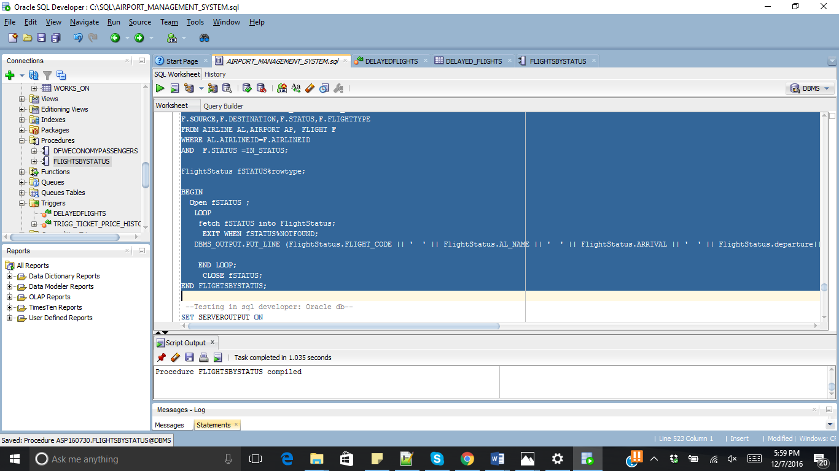

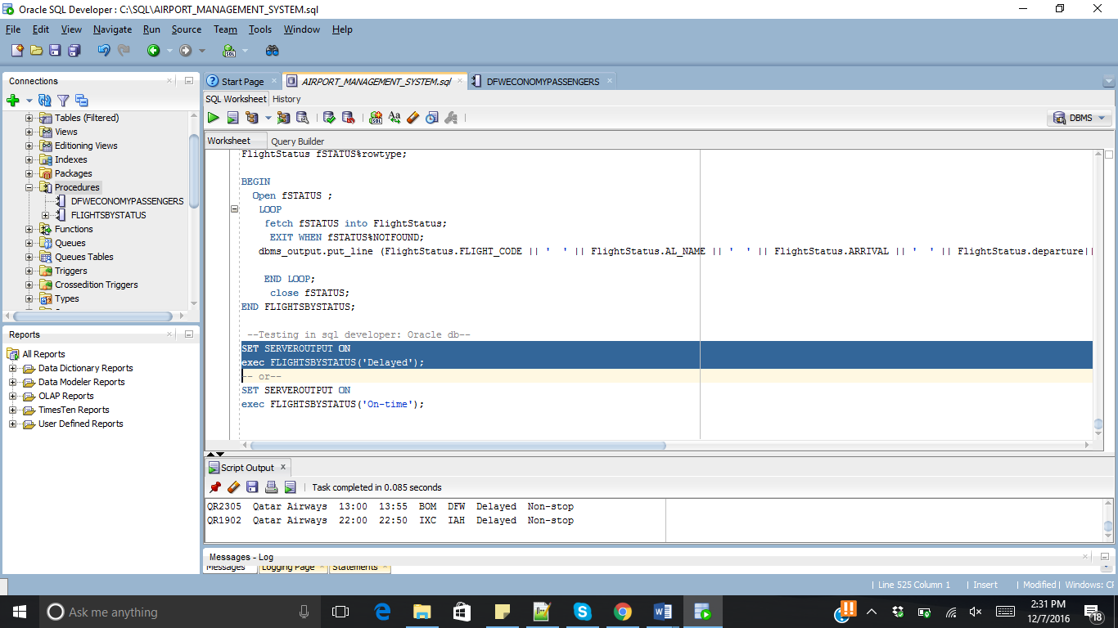

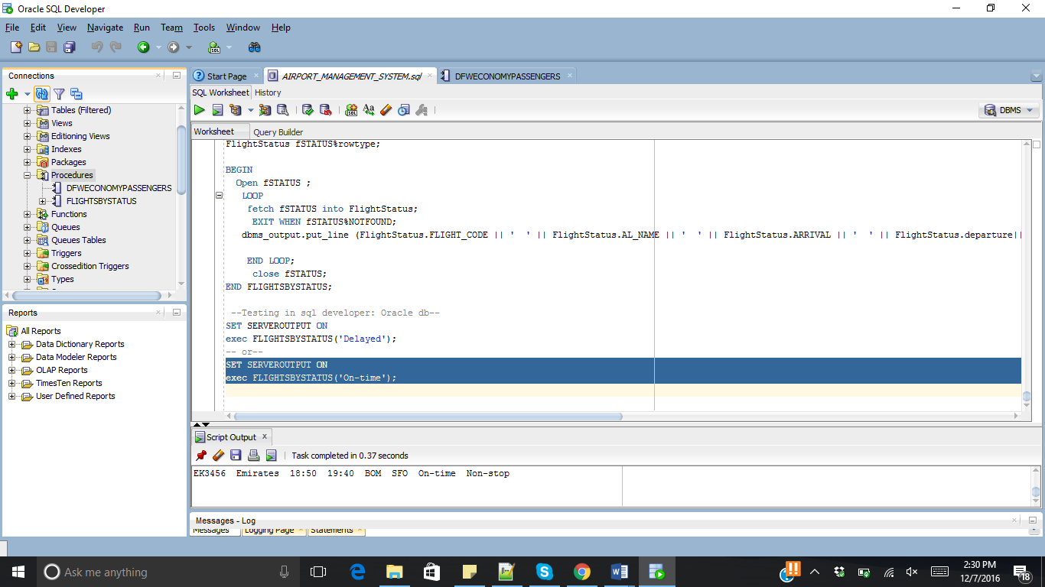

1. TRIGGERS

**10.1.** **Trigger for, when a flight is delayed, it is logged into different tables.**

CREATE OR REPLACE TRIGGER DELAYEDAIRCRAFTS

AFTER INSERT ON AIRCRAFT

FOR EACH ROW

DECLARE

BEGIN

if updating('STATUS')

then

insert into delayed_AIRCRAFTS (AIRCRAFT_CODE, R_NO, ARRIVAL, DEPARTURE, AIRLINEID ,report_time)

values(:new.AIRCRAFT_CODE,:new.R_NO,:new.ARRIVAL, :new.DEPARTURE, :new.airlineid, sysdate);

end if;

END;

/

**-- This is audit table for this trigger --**

CREATE TABLE DELAYED_AIRCRAFTS

(

AIRCRAFT_CODE VARCHAR(10) NOT NULL,

ARRIVAL VARCHAR2(10),

DEPARTURE VARCHAR2(10),

AIRLINEID VARCHAR(3),

R_NO INT,

REPORT_TIME DATE

);

INSERT INTO AIRCRAFT(AIRCRAFT_CODE, R_NO, ARRIVAL, DEPARTURE, STATUS, DURATION1, AIRCRAFTTYPE, LAYOVER_TIME, NO_OF_STOPS, MODEL1, AIRLINEID)

VALUES('AI127', 001, '02:10','03:15','Delayed','24hr','Connecting',3,1, 'BOEG-777','AI');

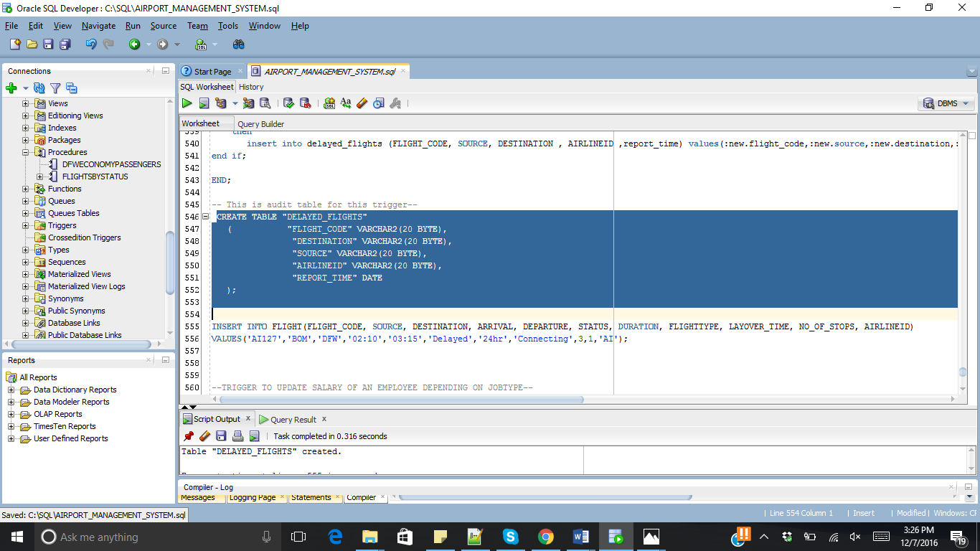

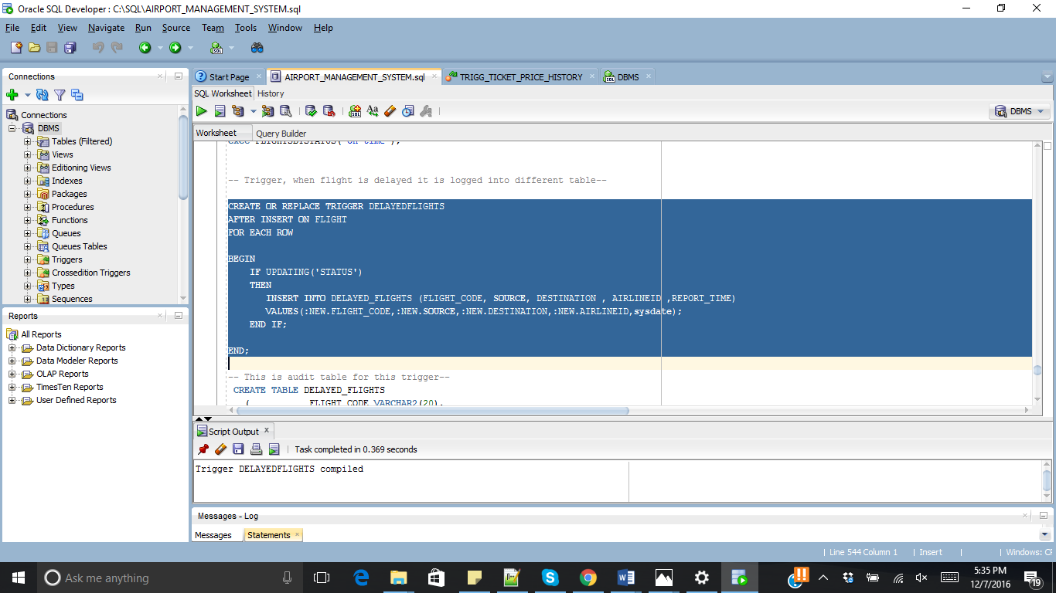

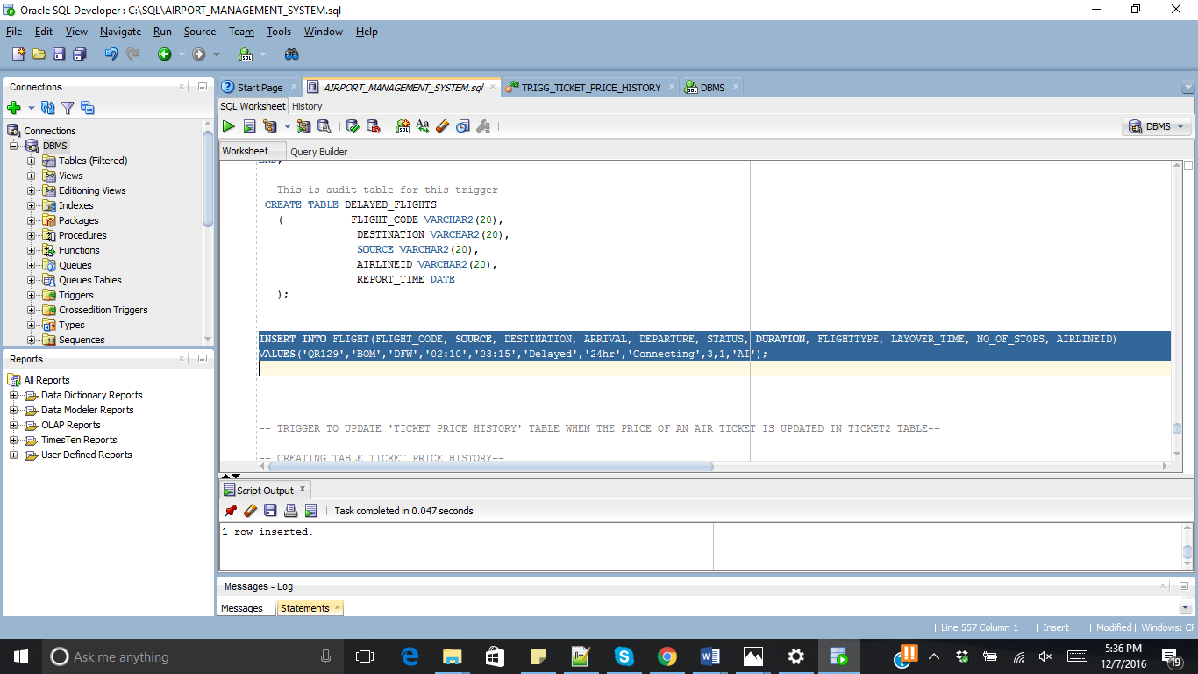

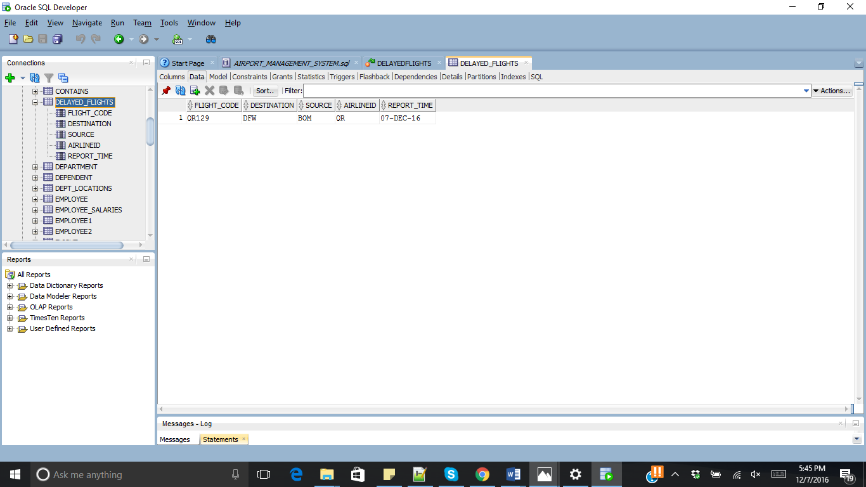

**10.2 Trigger to update TICKET_PRICE_HISTORY table when the price of the air ticket is updated in TICKET2 table.**

**-- CREATING TABLE TICKET_PRICE_HISTORY--**

CREATE TABLE TICKET_PRICE_HISTORY

(DATE_OF_BOOKING DATE NOT NULL,

SOURCE1 VARCHAR(3) NOT NULL,

DESTINATION VARCHAR(3) NOT NULL,

CLASS1 VARCHAR2(15) NOT NULL,

PRICE INT,

PRIMARY KEY(DATE_OF_BOOKING, SOURCE1, DESTINATION, CLASS1));

**-- CREATE A TRIGGER TICKET_PRICE_HISTORY –**

CREATE OR REPLACE TRIGGER TICKET_PRICE_HISTORY1

BEFORE UPDATE OF PRICE

ON TICKET2

FOR EACH ROW

DECLARE

BEGIN

INSERT INTO TICKET_PRICE_HISTORY ( DATE_OF_BOOKING, SOURCE1, DESTINATION, CLASS1, PRICE)

VALUES(:old.DATE_OF_BOOKING, :old.SOURCE1, :old.DESTINATION, :old.CLASS1, :old.PRICE);

END;

/

**--LET'S UPDATE A PRICE OR FARE OF AN AIR TICKET --**

UPDATE TICKET2

SET PRICE=150000

WHERE DATE_OF_BOOKING ='11-NOV-16'

AND SOURCE1='BOM'

AND DESTINATION='DFW'

AND CLASS1='ECONOMY';

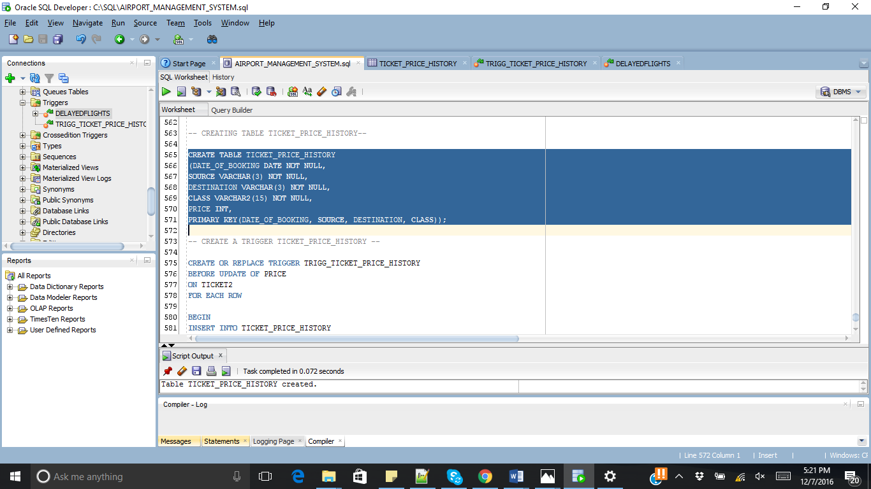

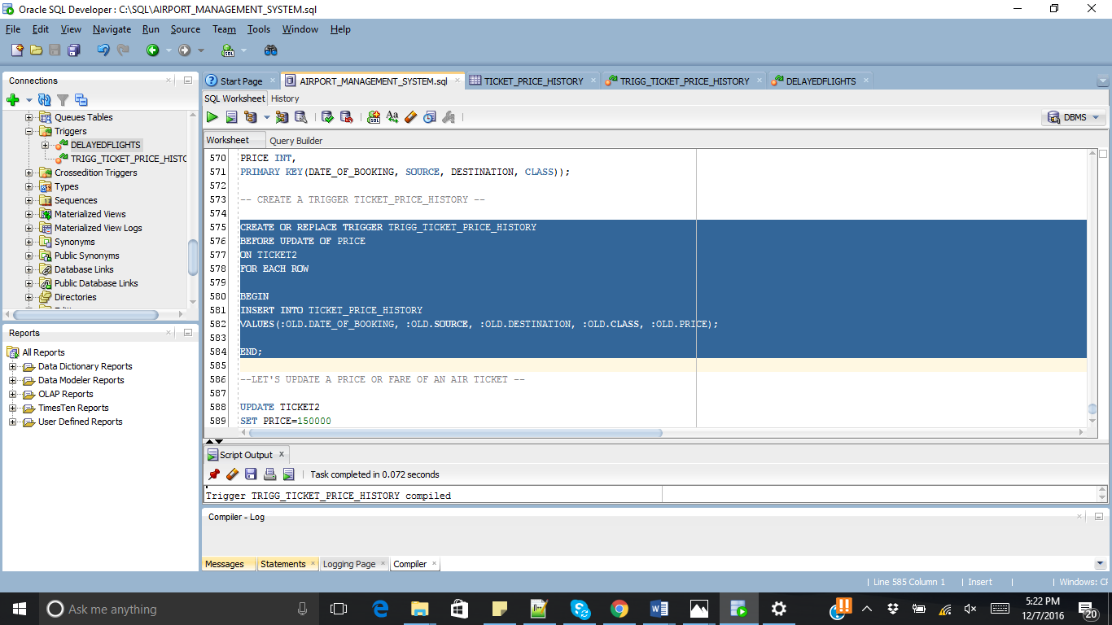

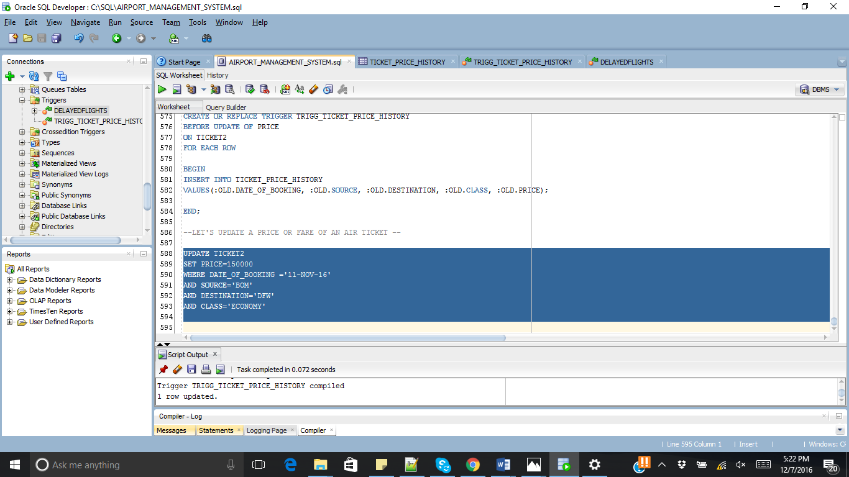

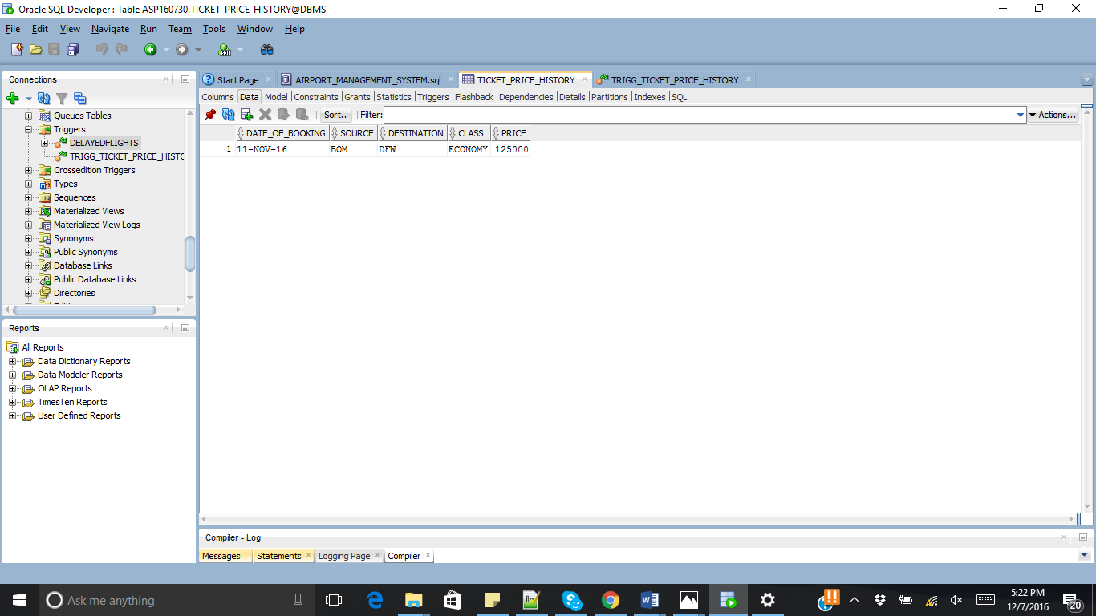

1. BUSINESS RULES
   1. **The length of an air ticket number should be exactly 13 digits.**



* 1. **Age of an employee working at any airport should not be greater than 65.**

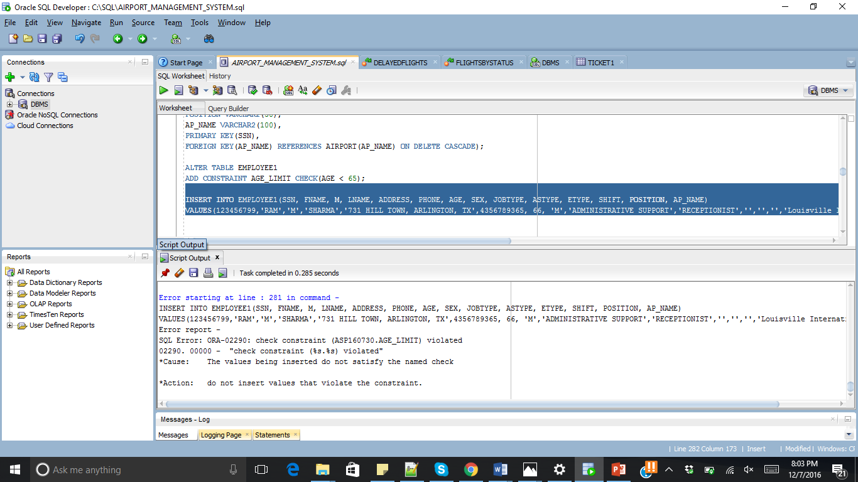

1. JDBC CONNECTION TO DATABASE

**-- Java code for connection --**

import java.sql.*;

public class connection

{

public static void main(String[] args) throws Exception

{

String driverclass = "oracle.jdbc.driver.OracleDriver";

String url = "jdbc:oracle:thin:@localhost:1521:xe";

String user = "homeuser";

String pass = "silas";

Class.forName(driverclass);

Connection con = DriverManager.getConnection(url,user,pass);

Statement st = con.createStatement();

ResultSet rs = st.executeQuery("SELECT a.AIRLINEID, a.AL_NAME, a.PH FROM AIRLINE a");

System.out.println("Airline ID " + " \tAirline Name " + "\t\t" + " Phone Number");

while(rs.next())

{

System.out.print(rs.getString(1));

System.out.print(" \t\t ");

System.out.print(rs.getString(2));

System.out.print("\t \t");

System.out.println(rs.getString(3));

}

}

}

**-- JDBC Connection Output –**

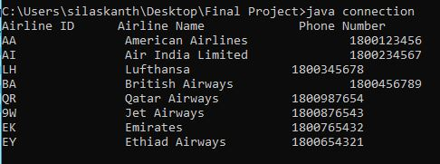

1. FRONT-END IMPLEMENTATION

The Database is connected to the front-end HTML pages using **JavaServer Pages** (JSP).

**JavaServer Pages** is a technology that helps software developers create dynamically generated web pages based on HTML, XML, or other document types. Released in 1999 by Sun Microsystems, JSP is similar to PHP and ASP, but it uses the Java programming language.

To deploy and run JavaServer Pages, a compatible web server with a servlet container, such as **Apache Tomcat** or **Jetty**, is required.

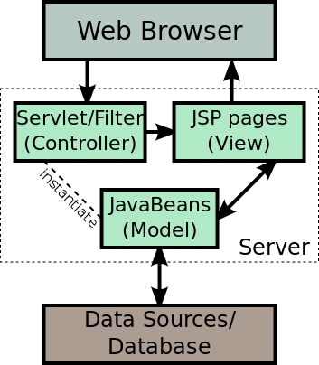

The JSP pages are hosted on Apache Tomcat v9.0 for our project.

Following are the pages:

1. Welcome Page.
2. Search Page for searching flights between Source and Destination.
3. Page to select to Insert or Delete data from database.
4. And the respective results pages.
5. **Welcome Page**
   1. **JSP Code**

<!DOCTYPE html>

<html>

<head>

<title>Welcome</title>

</head>

<body>

<h1>Welcome to Airlines Portal</h1>

<form name = "changeform1" action = "Search-Aircrafts.jsp" method = "POST">

<p>If you want to search Aircrafts between Airports, Click Below:</p>

<input type="submit" value="Search Flights" name="search" />

</form>

<p>If you click the "Search Flights" button, you will be able to search all aircrafts between the entered locations.</p>

<br><br><br><br>

<form name="changeform2">

<p>If you are an ADMINISTRATOR, Login to modify Data in Database.</p>

<input id="uname" type="text" placeholder="Username" name="username">

<input id="pass" type="text" placeholder="Password" name="psw">

<input type="button" value="Login" onclick="check()">

<p id="warningMsg">[Please Check before submitting]</p>

</form>

<script language="javascript">

// console.log(document.changeform2.pass.value);

function check()

{

if((document.changeform2.uname.value== "admin") && (document.changeform2.pass.value == "admin"))

{

console.log("hellohellohellohellohellohellohellohellohellohellohello");

window.location = '/Project/Choice.jsp';

}

else

{

console.log("Invalid login details...!!!");

document.getElementById('warningMsg').innerHTML = "Invalid login details...!!!";

}

}

</script>

</body>

</html>

* 1. **Webpage Working**

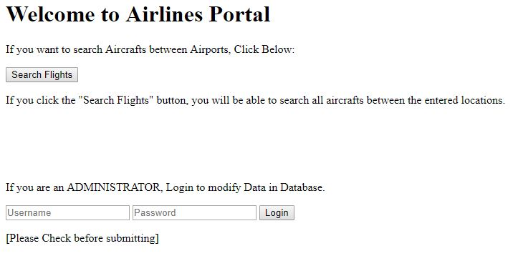

1. **Search Page**
   1. **JSP Code**

<!DOCTYPE html>

<html>

<head>

<title>Search</title>

</head>

<body>

<h1>Search Aircrafts</h1>

<form name = "searchform" action = "Result-Aircrafts.jsp" method = "POST">

Enter Source Code :<br>

<input type="text" name="source_loc" value="" size="3" maxlength="3" placeholder="SRC">

<br>

<br>

Enter Destination Code :<br>

<input type="text" name="dest_loc" value="" size="3" maxlength="3" placeholder="DST">

<br><br>

<input type="reset" value="Clear" name="clear" />

<input type="submit" value="Submit" name="submit" />

</form>

<p>If you click the "Submit" button, all aircrafts between the entered source and destination locations will be displayed. </p>

</body>

</html>

* 1. **Webpage Working**

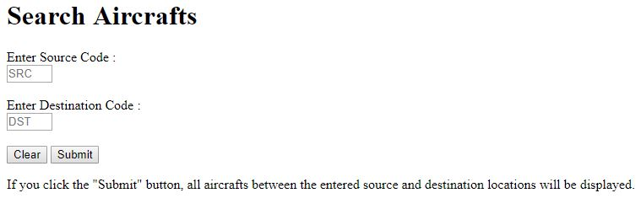

1. **Search Results**
   1. **JSP Code**

<%@ page import="java.sql.*" %>

<!DOCTYPE html>

<html>

<head>

<title>Search</title>

</head>

<body>

<h1>Aircraft Search Details</h1>

<%!

public class Actor

{

String url = "jdbc:oracle:thin:@localhost:1521:xe";

String username = "homeuser";

String password = "silas";

Connection conn = null;

PreparedStatement selectActors = null;

ResultSet rs = null;

public Actor()

{

try

{

conn = DriverManager.getConnection(url, username, password);

selectActors = conn.prepareStatement("SELECT a1.AL_NAME, a2.AIRCRAFT_CODE, r.SOURCE, r.DESTINATION, a2.ARRIVAL, a2.DEPARTURE, a2.DURATION1, a2.AIRCRAFTTYPE, a2.LAYOVER_TIME, a2.NO_OF_STOPS FROM AIRLINE a1, AIRCRAFT a2, ROUTE r WHERE r.SOURCE = ? AND r.DESTINATION = ? AND a1.AIRLINEID = a2.AIRLINEID AND a2.R_NO = r.R_NO");

}

catch (SQLException e)

{

e.printStackTrace();

}

}

public ResultSet getActors(String source_loc, String dest_loc)

{

try

{

selectActors.setString(1,source_loc);

selectActors.setString(2,dest_loc);

rs = selectActors.executeQuery();

}

catch (SQLException e)

{

e.printStackTrace();

}

return rs;

}

}

%>

<%

String s_loc = new String();

String d_loc = new String();

if (request.getParameter("source_loc") !=null)

{

s_loc = request.getParameter("source_loc");

}

if (request.getParameter("dest_loc") !=null)

{

d_loc = request.getParameter("dest_loc");

}

Actor actor = new Actor();

ResultSet actors = actor.getActors(s_loc, d_loc);

%>

<table border = 1 cellpadding = 5>

<tr>

<td>Airline</td>

<td>Aircraft Code</td>

<td>Source</td>

<td>Destination</td>

<td>Arrival Time</td>

<td>Departure Time</td>

<td>Duration</td>

<td>Aircraft Type</td>

<td>Layover Time (Hrs)</td>

<td>Number of Stops</td>

</tr>

<%

while(actors.next())

{

%>

<tr>

<td><%=actors.getString("AL_NAME")%></td>

<td><%=actors.getString("AIRCRAFT_CODE")%></td>

<td><%=actors.getString("SOURCE")%></td>

<td><%=actors.getString("DESTINATION")%></td>

<td><%=actors.getString("ARRIVAL")%></td>

<td><%=actors.getString("DEPARTURE")%></td>

<td><%=actors.getString("DURATION1")%></td>

<td><%=actors.getString("AIRCRAFTTYPE")%></td>

<td><%=actors.getString("LAYOVER_TIME")%></td>

<td><%=actors.getString("NO_OF_STOPS")%></td>

</tr>

<% } %>

</body>

</html>

* 1. **Webpage Working**

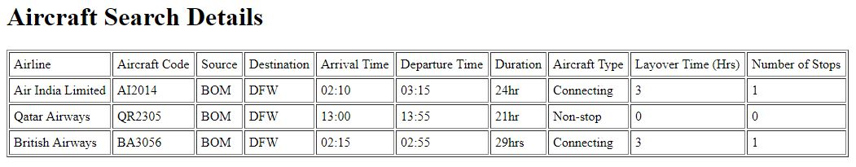

1. **Admin Page – Insert or Delete**
   1. **JSP Code**

<!DOCTYPE html>

<html>

<head>

<title>Choose</title>

</head>

<body>

<h1>Choose Operation</h1>

<form name = "choiceform1" action = "Insert-Aircrafts.jsp" method = "POST">

<p>Click Below to INSERT Aircraft into Database:</p>

<input type="submit" value="Insert Flights" name="insert" />

</form>

<br><br><br><br>

<form name = "choiceform2" action = "Delete-Aircrafts.jsp" method = "POST">

<p>Click Below to DELETE Aircraft into Database:</p>

<input type="submit" value="Delete Flights" name="delete" />

</form>

</body>

</html>

* 1. **Webpage Working**

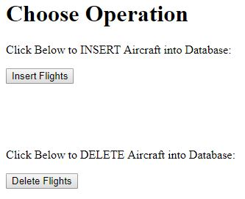

1. **Insert Data into Database**
   1. **JSP Code**

<!DOCTYPE html>

<html>

<head>

<title>Insert</title>

</head>

<body>

<h1>Insert Aircrafts</h1>

<br><br>

<form name = "insertform" action = "Display-Aircrafts.jsp" method = "POST">

Enter Aircraft Code :

<input type="text" name="a_code" value="" size="6" maxlength="6" placeholder="CODE">

<br>

<br>

Enter Route Number :

<input type="text" name="r_no" value="" size="3" maxlength="3" >

<br>

<br>

Enter Arrival Time :

<input type="text" name="arrival" value="" size="5" maxlength="5" placeholder="HH:MM">

<br>

<br>

Enter Departure Time :

<input type="text" name="departure" value="" size="5" maxlength="5" placeholder="HH:MM">

<br>

<br>

Select Status :

<select name="status">

<option value="On-time">On-time</option>

<option value="Delayed">Delayed</option>

</select>

<br>

<br>

Enter Travel Time :

<input type="text" name="duration" value="" size="5" maxlength="" placeholder="in Hrs">

<br>

<br>

Enter Aircraft Type :

<select name="a_type">

<option value="Connecting">Connecting</option>

<option value="Non-stop">Non-stop</option>

<option value="Direct">Direct</option>

</select>

<br>

<br>

Enter Layover Time :

<input type="text" name="layover_time" value="" size="3" maxlength="1" >

<br>

<br>

Enter Number of Stops :

<input type="text" name="stops" value="" size="3" maxlength="1" >

<br>

<br>

Select Aircraft Model :

<select name="model">

<option value="BOEG-747">BOEG-747</option>

<option value="BOEG-737">BOEG-737</option>

<option value="BOEG-777">BOEG-777</option>

<option value="BOEG-757">BOEG-757</option>

</select>

<br>

<br>

Enter Airline ID :

<input type="text" name="a_id" value="" size="3" maxlength="2" >

<br>

<br>

<input type="reset" value="Clear" name="clear" />

<input type="submit" value="Submit" name="submit" />

</form>

<p>If you click the "Submit" button, all the aircraft details entered will be inserted into the database.</p>

</body>

</html>

* 1. **Webpage Working**

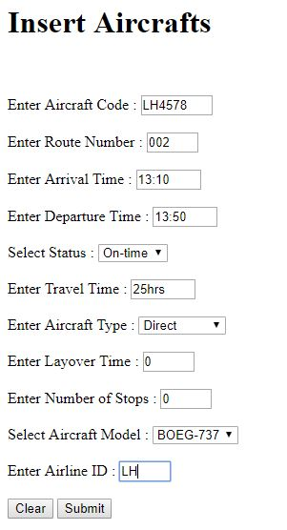

1. **Insertion Result Page**
   1. **JSP Code**

<html>

<head>

<title>Airline Results</title>

</head>

<body>

<h1>Data Inserted Successfully</h1>

<br><br>

<%@ page import = "java.sql.*" %>

<%

String a_code = request.getParameter("a_code");

String r_no = request.getParameter("r_no");

String arrival = request.getParameter("arrival");

String departure = request.getParameter("departure");

String status = request.getParameter("status");

String duration = request.getParameter("duration");

String a_type = request.getParameter("a_type");

String layover_time = request.getParameter("layover_time");

String stops = request.getParameter("stops");

String model = request.getParameter("model");

String a_id = request.getParameter("a_id");

Connection conn = DriverManager.getConnection("jdbc:oracle:thin:@localhost:1521:xe","homeuser","silas");

Statement stmt = conn.createStatement();

stmt.executeUpdate("INSERT INTO AIRCRAFT(AIRCRAFT_CODE, R_NO, ARRIVAL, DEPARTURE, STATUS, DURATION1, AIRCRAFTTYPE, LAYOVER_TIME, NO_OF_STOPS, MODEL1, AIRLINEID) VALUES('"+a_code+"','"+r_no+"','"+arrival+"','"+departure+"','"+status+"','"+duration+"','"+a_type+"','"+layover_time+"','"+stops+"','"+model+"','"+a_id+"')");

String sql = "SELECT a.AIRCRAFT_CODE, a.R_NO, a.ARRIVAL, a.DEPARTURE, a.STATUS, a.DURATION1, a.AIRCRAFTTYPE, a.LAYOVER_TIME, a.NO_OF_STOPS, a.MODEL1, a.AIRLINEID FROM AIRCRAFT a";

ResultSet rs = stmt.executeQuery(sql);

try

{

if(rs!=null)

{

%>

<table border = 1 cellpadding = 5>

<tr>

<td>Aircraft Code</td>

<td>Route</td>

<td>Arrival Time</td>

<td>Departure Time</td>

<td>Status</td>

<td>Duration</td>

<td>Aircraft Type</td>

<td>Layover Time (Hrs)</td>

<td>Number of Stops</td>

<td>Aircraft Model</td>

<td>Aircraft ID</td>

</tr>

<%

while(rs.next())

{

%>

<tr>

<td><%=rs.getString("AIRCRAFT_CODE")%></td>

<td><%=rs.getString("R_NO")%></td>

<td><%=rs.getString("ARRIVAL")%></td>

<td><%=rs.getString("DEPARTURE")%></td>

<td><%=rs.getString("STATUS")%></td>

<td><%=rs.getString("DURATION1")%></td>

<td><%=rs.getString("AIRCRAFTTYPE")%></td>

<td><%=rs.getString("LAYOVER_TIME")%></td>

<td><%=rs.getString("NO_OF_STOPS")%></td>

<td><%=rs.getString("MODEL1")%></td>

<td><%=rs.getString("AIRLINEID")%></td>

</tr>

<%

}

}

}

catch(SQLException e)

{

e.printStackTrace();

}

stmt.close();

rs.close();

conn.close();

stmt=null;

rs=null;

conn=null;

%>

</table>

</body>

</html>

* 1. **Webpage Working**

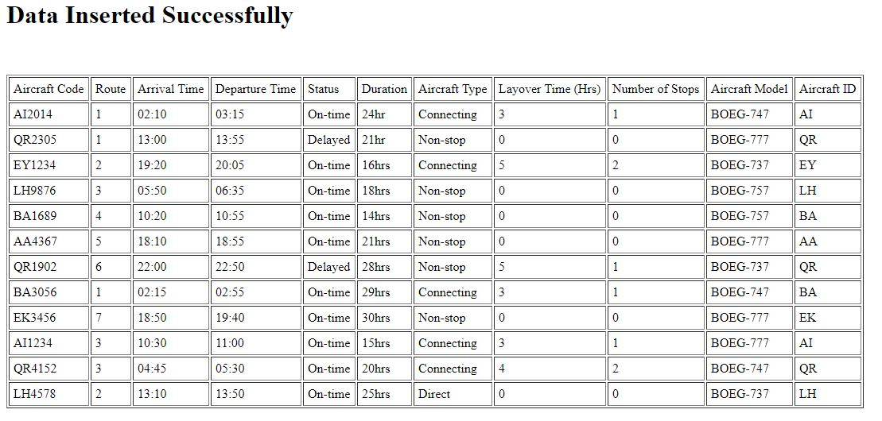

1. **Delete Data from Database**
   1. **JSP Code**

<%@ page import="java.sql.*" %>

<!DOCTYPE html>

<html>

<head>

<title>Delete</title>

</head>

<body onload="dispRes()">

<h1>Delete Aircraft</h1>

<%!

public class Actor

{

String url = "jdbc:oracle:thin:@localhost:1521:xe";

String username = "homeuser";

String password = "silas";

Connection conn = null;

PreparedStatement selectActors = null;

PreparedStatement deleteActor = null;

ResultSet rs = null;

public Actor()

{

try

{

conn = DriverManager.getConnection(url, username, password);

selectActors = conn.prepareStatement("SELECT AIRCRAFT_CODE FROM AIRCRAFT ");

deleteActor = conn.prepareStatement("DELETE FROM AIRCRAFT WHERE AIRCRAFT_CODE = ?");

}

catch (SQLException e)

{

e.printStackTrace();

}

}

public ResultSet getActors()

{

try

{

rs = selectActors.executeQuery();

}

catch (SQLException e)

{

e.printStackTrace();

}

return rs;

}

public void deleteActor(String a_code)

{

try

{

deleteActor.setString(1, a_code);

deleteActor.executeUpdate();

}

catch (SQLException e)

{

e.printStackTrace();

}

}

}

%>

<%

Actor actor = new Actor();

ResultSet actors = actor.getActors();

if(request.getParameter("submit") != null)

{

String a_code = request.getParameter("a_code");

actor.deleteActor(a_code);

}

%>

<form name="myform1" action="Delete-Aircrafts.jsp" method="POST">

<table border = 0>

<tbody>

<tr>

<td>Select Aircraft Code to delete : </td>

<td>

<select name="a_code">

<% while (actors.next())

{%>

<option value="<%= actors.getString("AIRCRAFT_CODE")%>">

<%= actors.getString("AIRCRAFT_CODE")%>

</option>

<% } %>

</select>

</td>

</tr>

</tbody>

</table>

<br>

<input type="submit" value="Submit" name="submit" />

<br><br><br>

<p>To veiw UPDATED database, Click below. </p>

<button type="submit" formaction="Display-Aircrafts-2.jsp">View</button>

</form>

</body>

</html>

* 1. **Webpage Working**

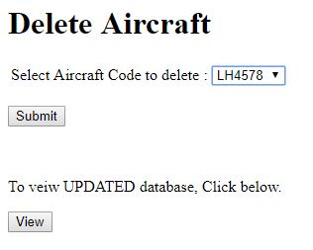

1. **Deletion Result Page**
   1. **JSP Code**

<html>

<head>

<title>Airline Results</title>

</head>

<body>

<h1>Data Deleted Successfully</h1>

<br><br>

<%@ page import = "java.sql.*" %>

<%

Connection conn = DriverManager.getConnection("jdbc:oracle:thin:@localhost:1521:xe","homeuser","silas");

Statement stmt = conn.createStatement();

String sql = "SELECT a.AIRCRAFT_CODE, a.R_NO, a.ARRIVAL, a.DEPARTURE, a.STATUS, a.DURATION1, a.AIRCRAFTTYPE, a.LAYOVER_TIME, a.NO_OF_STOPS, a.MODEL1, a.AIRLINEID FROM AIRCRAFT a";

ResultSet rs = stmt.executeQuery(sql);

try

{

if(rs!=null)

{

%>

<table border = 1 cellpadding = 5>

<tr>

<td>Aircraft Code</td>

<td>Route</td>

<td>Arrival Time</td>

<td>Departure Time</td>

<td>Status</td>

<td>Duration</td>

<td>Aircraft Type</td>

<td>Layover Time (Hrs)</td>

<td>Number of Stops</td>

<td>Aircraft Model</td>

<td>Aircraft ID</td>

</tr>

<%

while(rs.next())

{

%>

<tr>

<td><%=rs.getString("AIRCRAFT_CODE")%></td>

<td><%=rs.getString("R_NO")%></td>

<td><%=rs.getString("ARRIVAL")%></td>

<td><%=rs.getString("DEPARTURE")%></td>

<td><%=rs.getString("STATUS")%></td>

<td><%=rs.getString("DURATION1")%></td>

<td><%=rs.getString("AIRCRAFTTYPE")%></td>

<td><%=rs.getString("LAYOVER_TIME")%></td>

<td><%=rs.getString("NO_OF_STOPS")%></td>

<td><%=rs.getString("MODEL1")%></td>

<td><%=rs.getString("AIRLINEID")%></td>

</tr>

<%

}

}

}

catch(SQLException e)

{

e.printStackTrace();

}

stmt.close();

rs.close();

conn.close();

stmt=null;

rs=null;

conn=null;

%>

</table>

</body>

</html>

* 1. **Webpage Working**

